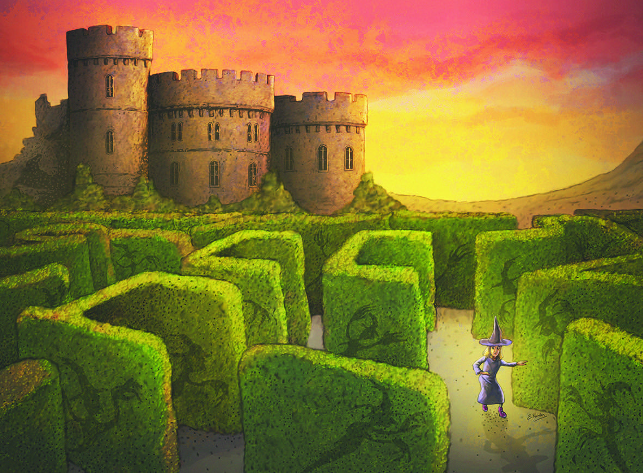
Contents
A Novel Study

Thumble Tumble & The Ollpheist

By A.H. Proctor

Pupil Copy

The Extraordinary Little Witch!

Thumble Tumble and the Ollpheist - Introduction
Chapter 1 The Broken Coven
Chapter 2 The Ring
Chapter 3 The Good Witches
Chapter 4 Lochs, Castles and Rumours
Chapter 5 Rhino Dust
Chapter 6 Let the Games Begin
Chapter 7 The secret of the Ollpheist
Chapter 8 Spoilsports
Chapter 9 Melting Pot
Chapter 10 Snatched
Chapter 11 Lazlo's Cup
Chapter 12 The Return of the Protector

Published by Forth Books

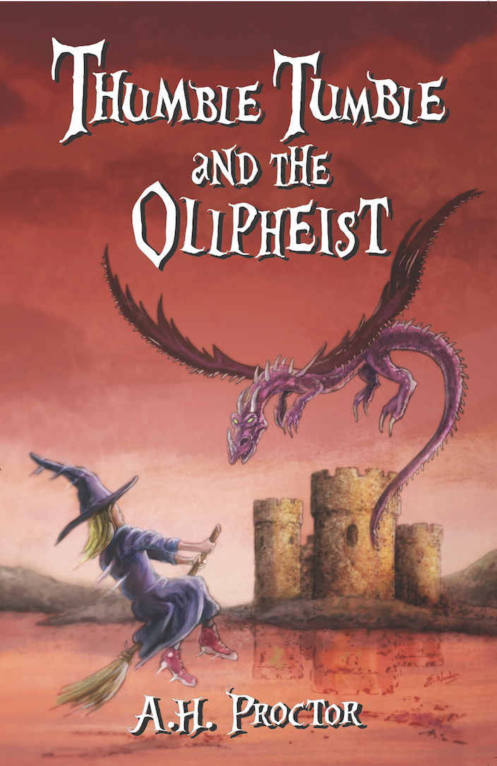
Before Reading – Good readers ask questions and look for clues before opening the book!

Discuss the following questions with your reading partner/partners:

- Is it a fiction or non-fiction text? How can you tell?

- What can I predict from the title, the picture, the blurb and the author?

- What clues did you use to make predictions?

- What can I picture in my head from the title?

- What do I know already about this type of genre?

- What do I know already about this topic?

- What do I want to find out about the characters/plot/setting?

Write your predictions in the crystal ball and as you read, look back to see if your predictions came true!

Chapter 1 - The Broken Coven

- Word Study
Work with a partner to create a definition for each word/phrase, using one or more of the word attack strategies.

Word/Phrase | Page | Our definition | Word attack strategy
coven | 7
arbitrator | 7
amulet | 9
alchemist | 11
foul | 10

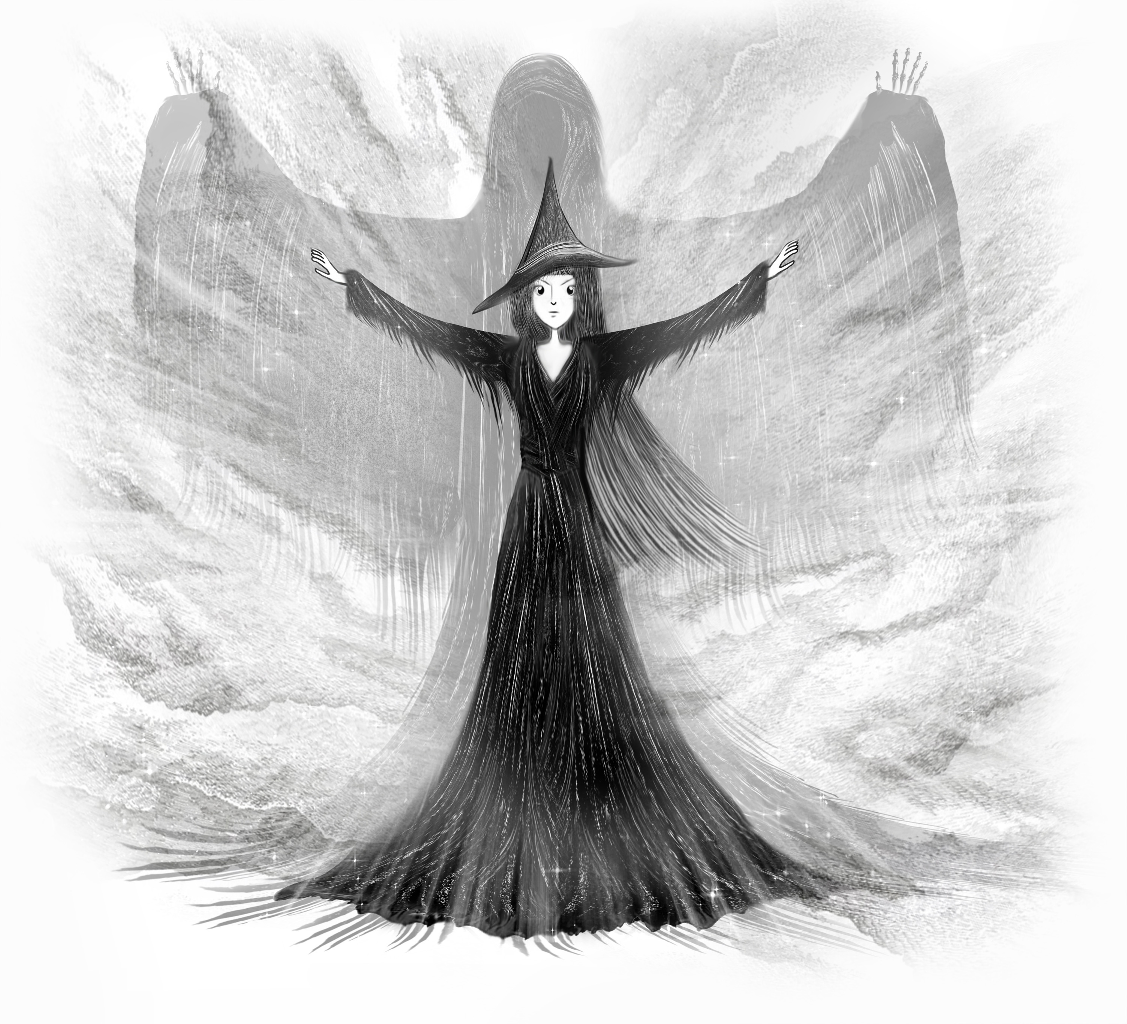
- Characterisation

Character study: Work with your reading partner to compare how the author describes the ‘good witches’ and the ‘evil witches’. Find evidence from Chapter 1 to complete the character mind map.

- After reading:
Discuss techniques/tools used by the author to create the characters in Chapter 1.

Chapter 2 - The Ring
- The author uses similes to help us visualise the setting, describe the action and to bring the characters to life in our imagination. With a partner skim Chapter 2 to provide at least 4 interesting similes.

- List the names of the evil witches. With your reading partner/trio discuss why you think the author chose these particular names for the witches. How do the names affect how you visualise each of the characters?

- Word study – List the powerful verbs which the author uses instead of “said”: e.g. grunted

- List five powerful verbs used by the author to describe how the characters move e.g. hurtled

- Re-read the description of the Tree Trolls and create a drawing of how you visualise the two characters.

- Discuss with your reading partner/trio, the techniques authors use to create interesting characters.

Chapter 3 - The Good Witches

- Word Finder: Use your word attack strategies to write your own definition of the following words:

Word | Definition
buzzard (page 20)
aroma (Page 20)
wafting (Page 20)

Grammar & Punctuation Focus:

- Write out the poem at the beginning of chapter 3, underlining the nouns in green and the verbs in blue. If you spot any adjectives, underline them in red.
Close Reading

- How old are Isla and Bessie?
- What is strange about the witches, given their age?
- What age can a witch live to?
- What is affected as they get older?
- Why do you think the author chose the name ‘Scoffalicious Chocolate’?
- What is so special about the chocolate?
- Who was Auntie Isla making the chocolate for?
- What is Bessie’s companion called?
- What is unusual about him?
- What do you think caused him to become stuck on the beach?
- Why was Bessie considered to be an ‘unconventional’ witch?
- Why does Thumble Tumble offer to deliver the Scoffalicious Chocolate to the Great Games?
- From reading chapter 3 use two words to describe Thumble Tumble. Give reasons for your answer.
- Create 3 questions about the text for your partner/trio.
Label each question as: Literal, Inferential or Evaluative. Remember some questions may be both inferential and evaluative.

- Create your own magical chocolate bar.
What is it called? Is it delicious or horrible? Describe what it tastes like, using a range of interesting adjectives and similes.

Focus: Setting

- With your partner/trio, you will discuss the tools and techniques used by the author to describe the cottage and its setting. Has the author helped you to visualise the scene? Scan the text to give examples to support your answer.

- Authors create setting descriptions using the five senses. Use the setting descriptions in Chapter 3 to give at least one example for each category in the table below:

Senses | Examples from the text
hear
see
smell
touch/feel
taste

Chapter 4 - Lochs, Castles and Rumours

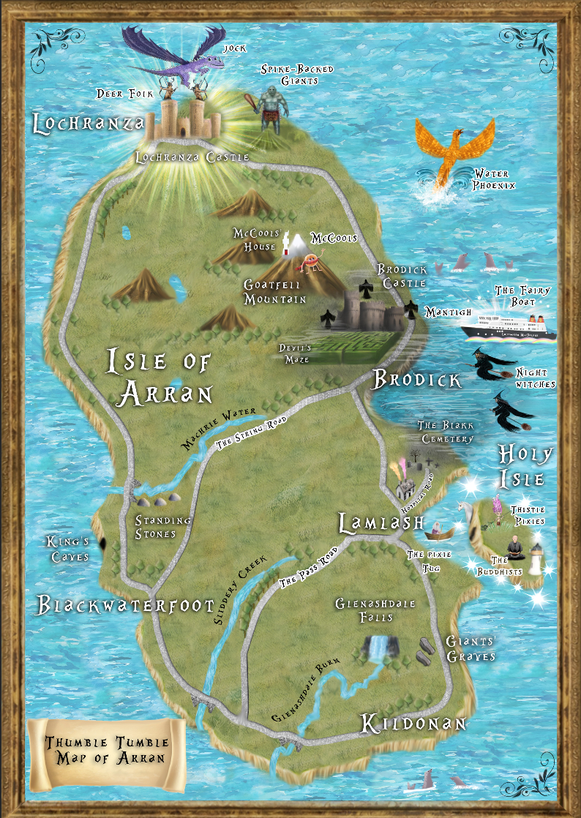
1. Using the ‘Magical Map’ of Arran find the grid references for the following places:

- Lochranza Castle
- Glenashdale Falls
- Blakk Cemetery

2. Draw a compass in Grid Reference G10

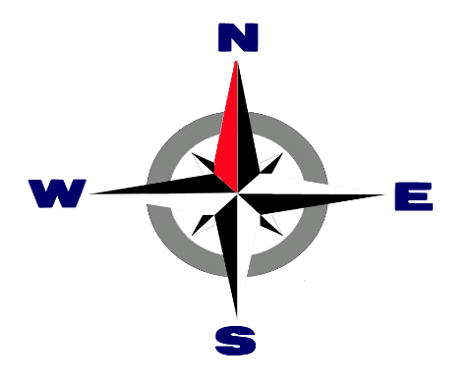
This Photo by Unknown Author is licensed under CC BY-SA

3. Thumble Tumble’s house is in grid reference F7. What direction would she fly from her house to get to the following places:

- Lochranza Castle
- The Kings Caves
- Glenashdale Falls

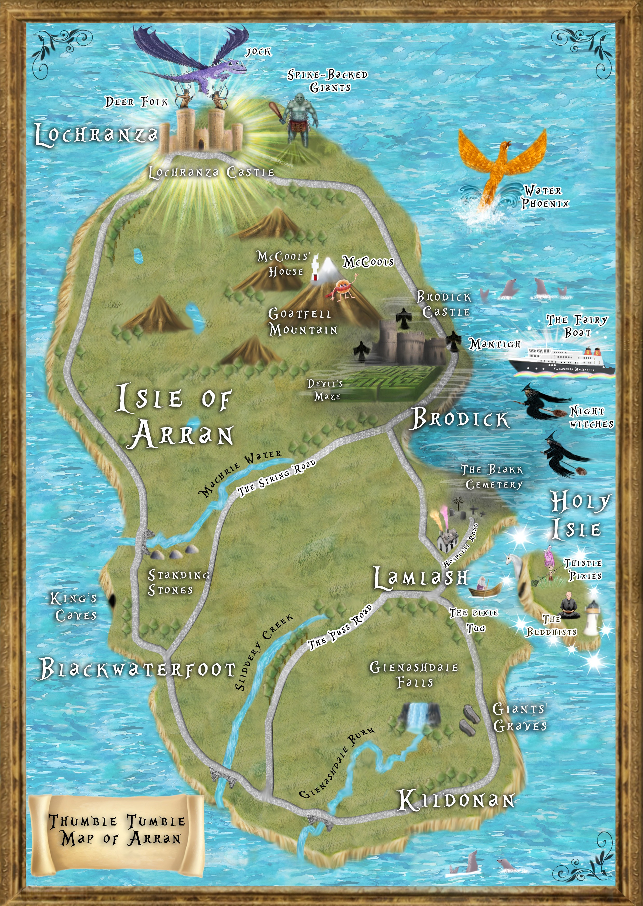
 | A | B | C | D | E | F | G | H
1
2
3
4
5
6
7
8
9
10

- Use your word attack strategies to write your own definition of the following words:

Word | Definition
detected - page 30
fiendish - page 30
ingenious - page 32
venom - page 33

Grammar and Punctuation – Similes

- Write out the last paragraph on page 33. Underline the similes.
Literacy Circle

After listening to the teacher reading chapter 4 discuss the following questions with your reading partner/trio:

- Why do you think the author chose the title, ‘Lochs, Castles and Rumours’?
- Why is it difficult to work out if the story is set in olden or modern times?
- Evaluate how the author has described the castle and the setting. Has her description helped you create a vivid picture of it in your mind as you read?
- Look at the illustration on page 33. Discuss what is in the picture. Is it scary? Explain why?
- Look at each question above and discuss if they are literal, inferential or evaluative. (Some questions can be evaluative and inferential)
- Predict what will happen next in the story.

- Listening Activity:

Write a short description of what you think the fifth head of the Ollpheist could look like. Read your description to your partner/trio. They will make a drawing of the head by listening to your description. Include details of size, colour, number of eyes/ears/claws etc. Has your partner included all the correct details in their drawing?

Chapter 5 – Rhino Dust

- Scan page 37, paragraph 3, from ‘as their name suggests’. List the adjectives and similes which the author uses to describe the Spike Backs.

- Throughout the book the author has used a variety of techniques to create imaginative and memorable characters. With your partner/trio you will brainstorm the techniques and tools which the author has used in the text, from the beginning of the book.

- Writing Activity:

Create your own type of giant

- Summary of Events

Create a flow chart, giving a brief description of events which lead to Thumble Tumble landing on top of the Ollpheist’s head.

START

Chapter 6 – Let the Games Begin
Word Study

- Use your word attack strategies to come up with synonyms for the words in the table:
Word | Synonym
arrogant - page 41
extremely - page 42
lobbed - page 42
hollered - page 45

- Describe your first impressions of MJ. Give evidence from the text to support your answer.

- Compare and contrast the Deer Folk from each of the different islands.
Island | Deer Folk Description
Eigg
Islay
Muck
Rum

- Give two examples of how the author uses ‘stereotype’ to help the reader visualise the different characters.

- Who do you think would be a better class mate: MJ or Serena? Give reasons for your answer.

- Why are the Deer Folk from Islay known as the ‘big yins’? Explain your understanding of the phrase.

- Bruiser’s arms were described as being ‘as thick as a tree’. Write your own simile to describe one of the characters from Chapter 6.

- The Lochranza flag is split into four sections, each with an illustration that has something to do with Lochranza Castle. Think of where you live/or where your school is and design a flag with four images on it. Each image is to represent something about your home/school. Present your flag to the class/partner/trio and describe what is in each section, giving an explanation as to why you have chosen each of the images.

Reading into Writing

With your partner/trio, re-read the description of the final of the Tug-O-War.

Digital Text

Work with your partner/trio to create and record your own ‘sports commentary’ of the final of the ‘Tug-O-War’. However, your commentary will present a very different chain of events, with your own alternative ending.

Chapter 7 – The Secret of the Ollpheist

Discussion:

- Re-read the Ollpheist’s recount of how he became the ‘legend of the Ollpheist’ on page 51. Can you think of any similar legends?

- List the features of a legend

Chapter 8 – Spoilsports
Discussion Before reading Chapter 8:

- Re-read the last paragraph of Chapter 7 on page 53. What tool does the author use to suggest that something awful is about to happen? Make a prediction about what will happen next?

Discussion After Reading Chapter 8:

- Reflect on your prediction. Were you correct?

- Scan the first paragraph. Explain why the author has used italics.

- If the author had written, ‘MJ was still in the changing room when he realised they were under attack from the Night Witches’. Discuss how this shortened version lacks details. Which version would readers prefer?

- Now scan the rest of page 54. Discuss the author’s use of imagery.

- Identify how the author creates a feeling of chaos in the arena above MJ

Writing a Legend

Use success criteria, and the ‘Story Mountain’ planning sheet to write your own Scottish legend about a mythical creature.

Story Mountain for: ____The Legend of_________________________________________ Name: ________________________________
Problem
________________________________________________________________________________________________________________________________________
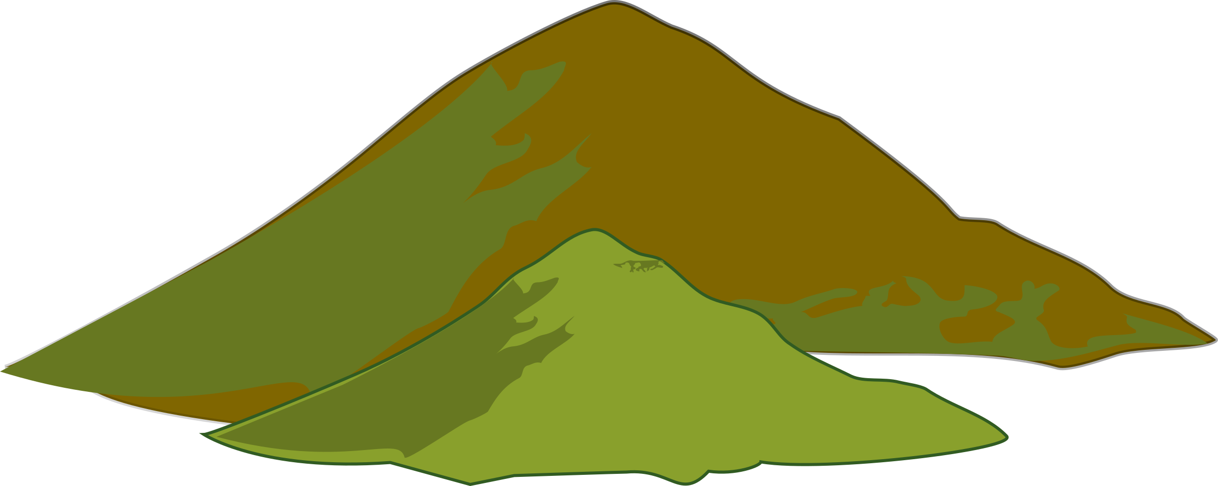
Story Mountain
Build Up
________________________________________________________________________________________________________________________________________
Characters

Settings

Resolution
________________________________________________________________________________________________________________________________________
Ending
________________________________________________________________________________________________________________________________________
Introduction
________________________________________________________________________________________________________________________________________

TRUE, FALSE, JUSTIFY

Tick the statements below as being True or False. Justify your answers to your partner/trio by using evidence from the text.

Statement | True | False
MJ wasn't that bothered about being beaten by a girl
MJ was used to hearing actual screams of fear
Thunder bolts leave a circle of black powder?
The Deer Folk were under attack from Spike Back Giants
MJ Waived his arms to draw the Night Witches away from the panicked crowds
MJ was arrogant
Serena appeared out of nowhere with a spare bow for MJ
Night Witches stay within the dark clouds when fighting
Serena hit four Night Witches sending them spinning out of control
Mac's blood poured onto the arena floor when he was hit on the shoulder
A bolt singed MJ's fingers before hitting Mac on the leg just below the knee
MJ shouted to Serena to get Geeza out of the arena
Serena stabbed Geeza in the back with an arrow
MJ was like a raging bull, charging at the Night Witches after his two friends were injured

Chapter 9 – Melting Pot

- Scan page 59 from “Thank goodness they’ve gone” to the end of page 60. List the ten contractions on the pages in order of appearance

- Choose any 3 contractions and use them in a short paragraph to describe what you think happens next.

- Read the remainder of the chapter and discuss/compare with your partner/trio what ‘actually’ happened next. Compare with your prediction

- Scan page 63. Use your word attack strategies to interpret what the following words mean:

- glee
- chant
- summoned
- disintegrated
- charred

- Write a short paragraph about witches that includes at least three of the above words

Chapter 10 - Snatched

Alfy was having so much fun playing with the ‘Snozel Frazens’ that she had tears streaming down her face.

1. Create your own ‘mini beast’. Describe what it would do to make you laugh.

2. Draw your mini beast here:

Close Reading

- Who saved Alfy and why?
- Describe how Alfy managed to find herself in a sinking swamp
- Write down the definition of the word ‘guest’
- In the chapter the author puts the word ‘guest’ in italics when Mogdred says “Alfy will remain a ‘guest’ forever”. Explain why the author has used italics when Mogdred says this with reference to what Mogdred really means by the word ‘guest’

Chapter 11 – Lazlo’s Cup
- Read page 68 only, then predict why Thumble Tumble feels like she has met Mac, MJ and Geeza before?
Continue reading the remainder of the chapter and answer the questions below.

- Why do you think MJ decided not to join in the games?

- Describe how MJ’s character changed throughout the story. Use the table below to give examples of how he has changed.

MJ’s Character Transformation
Chapter 6 | Chapter 8 – Chapter 11

- What do you think was the turning point for MJ’s transformation?

- Give an example of other books you have read, or films you have watched which include a character turning point, or transformation.

- What does the author mean when she uses the phrase, ‘Looks can be deceiving’ when referring to the Lazlo Cup?

- Thumble Tumble’s aunts use a ‘Pausing Spell’ so that they can enter the royal box during the Great Games. Devise a spell that would allow you to enter the Great Games. Give your spell a magical name and describe what it does.

Chapter 12 – The Return of the Protector
- Summarise how the book ends.

- Write an alternative ending to the book where it does not end in a cliffhanger.

- Create an online Blog or Vlog to review the book on your school website.

The End

