A Novel Study

THUMBLE TUMBLE AND THE OLLPHEIST

By A.H. Proctor

Teacher’s Pac

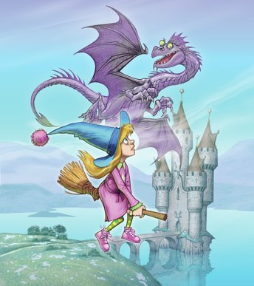

Contents

Thumble Tumble and the Ollpheist - Introduction
Chapter 1 The Broken Coven
Chapter 2 The Ring
Chapter 3 The Good Witches
Chapter 4 Lochs, Castles and Rumours
Chapter 5 Rhino Dust
Chapter 6 Let the Games Begin
Chapter 7 The secret of the Ollpheist
Chapter 8 Spoilsports
Chapter 9 Melting Pot
Chapter 10 Snatched
Chapter 11 Lazlo's Cup
Chapter 12 The Return of the Protector
Curricular Links

The teacher may reproduce copies of materials in this book for classroom use only. The reproduction of any part for an entire school or school system is strictly prohibited. No part of this publication may be transmitted, stored, or recorded in any form without written permission from the publisher.

Published by Forth Books

Before Reading – Good readers ask
questions and look for clues
before opening the book!

Discuss the following questions with your reading partner/partners:

- Is it a fiction or non-fiction text? How can you tell?

- What can I predict from the title, the picture, the blurb and the author?

- What clues did you use to make predictions?

- What can I picture in my head from the title?

- What do I know already about this type of genre?

- What do I know already about this topic?

- What do I want to find out about the characters/plot/setting?

Write your predictions in the crystal ball and as you read look back to see if your predictions came true!

Chapter 1 - The Broken Coven

- Word Study
Work with a partner to create a definition for each word/phrase, using one or more of the word attack strategies.

Word/Phrase | Page | Our definition | Word attack strategy
coven | 7 | e.g. A gathering of witches. | e.g. read sentence before and after the word.
arbitrator | 7
amulet | 9
alchemist | 11
foul | 10

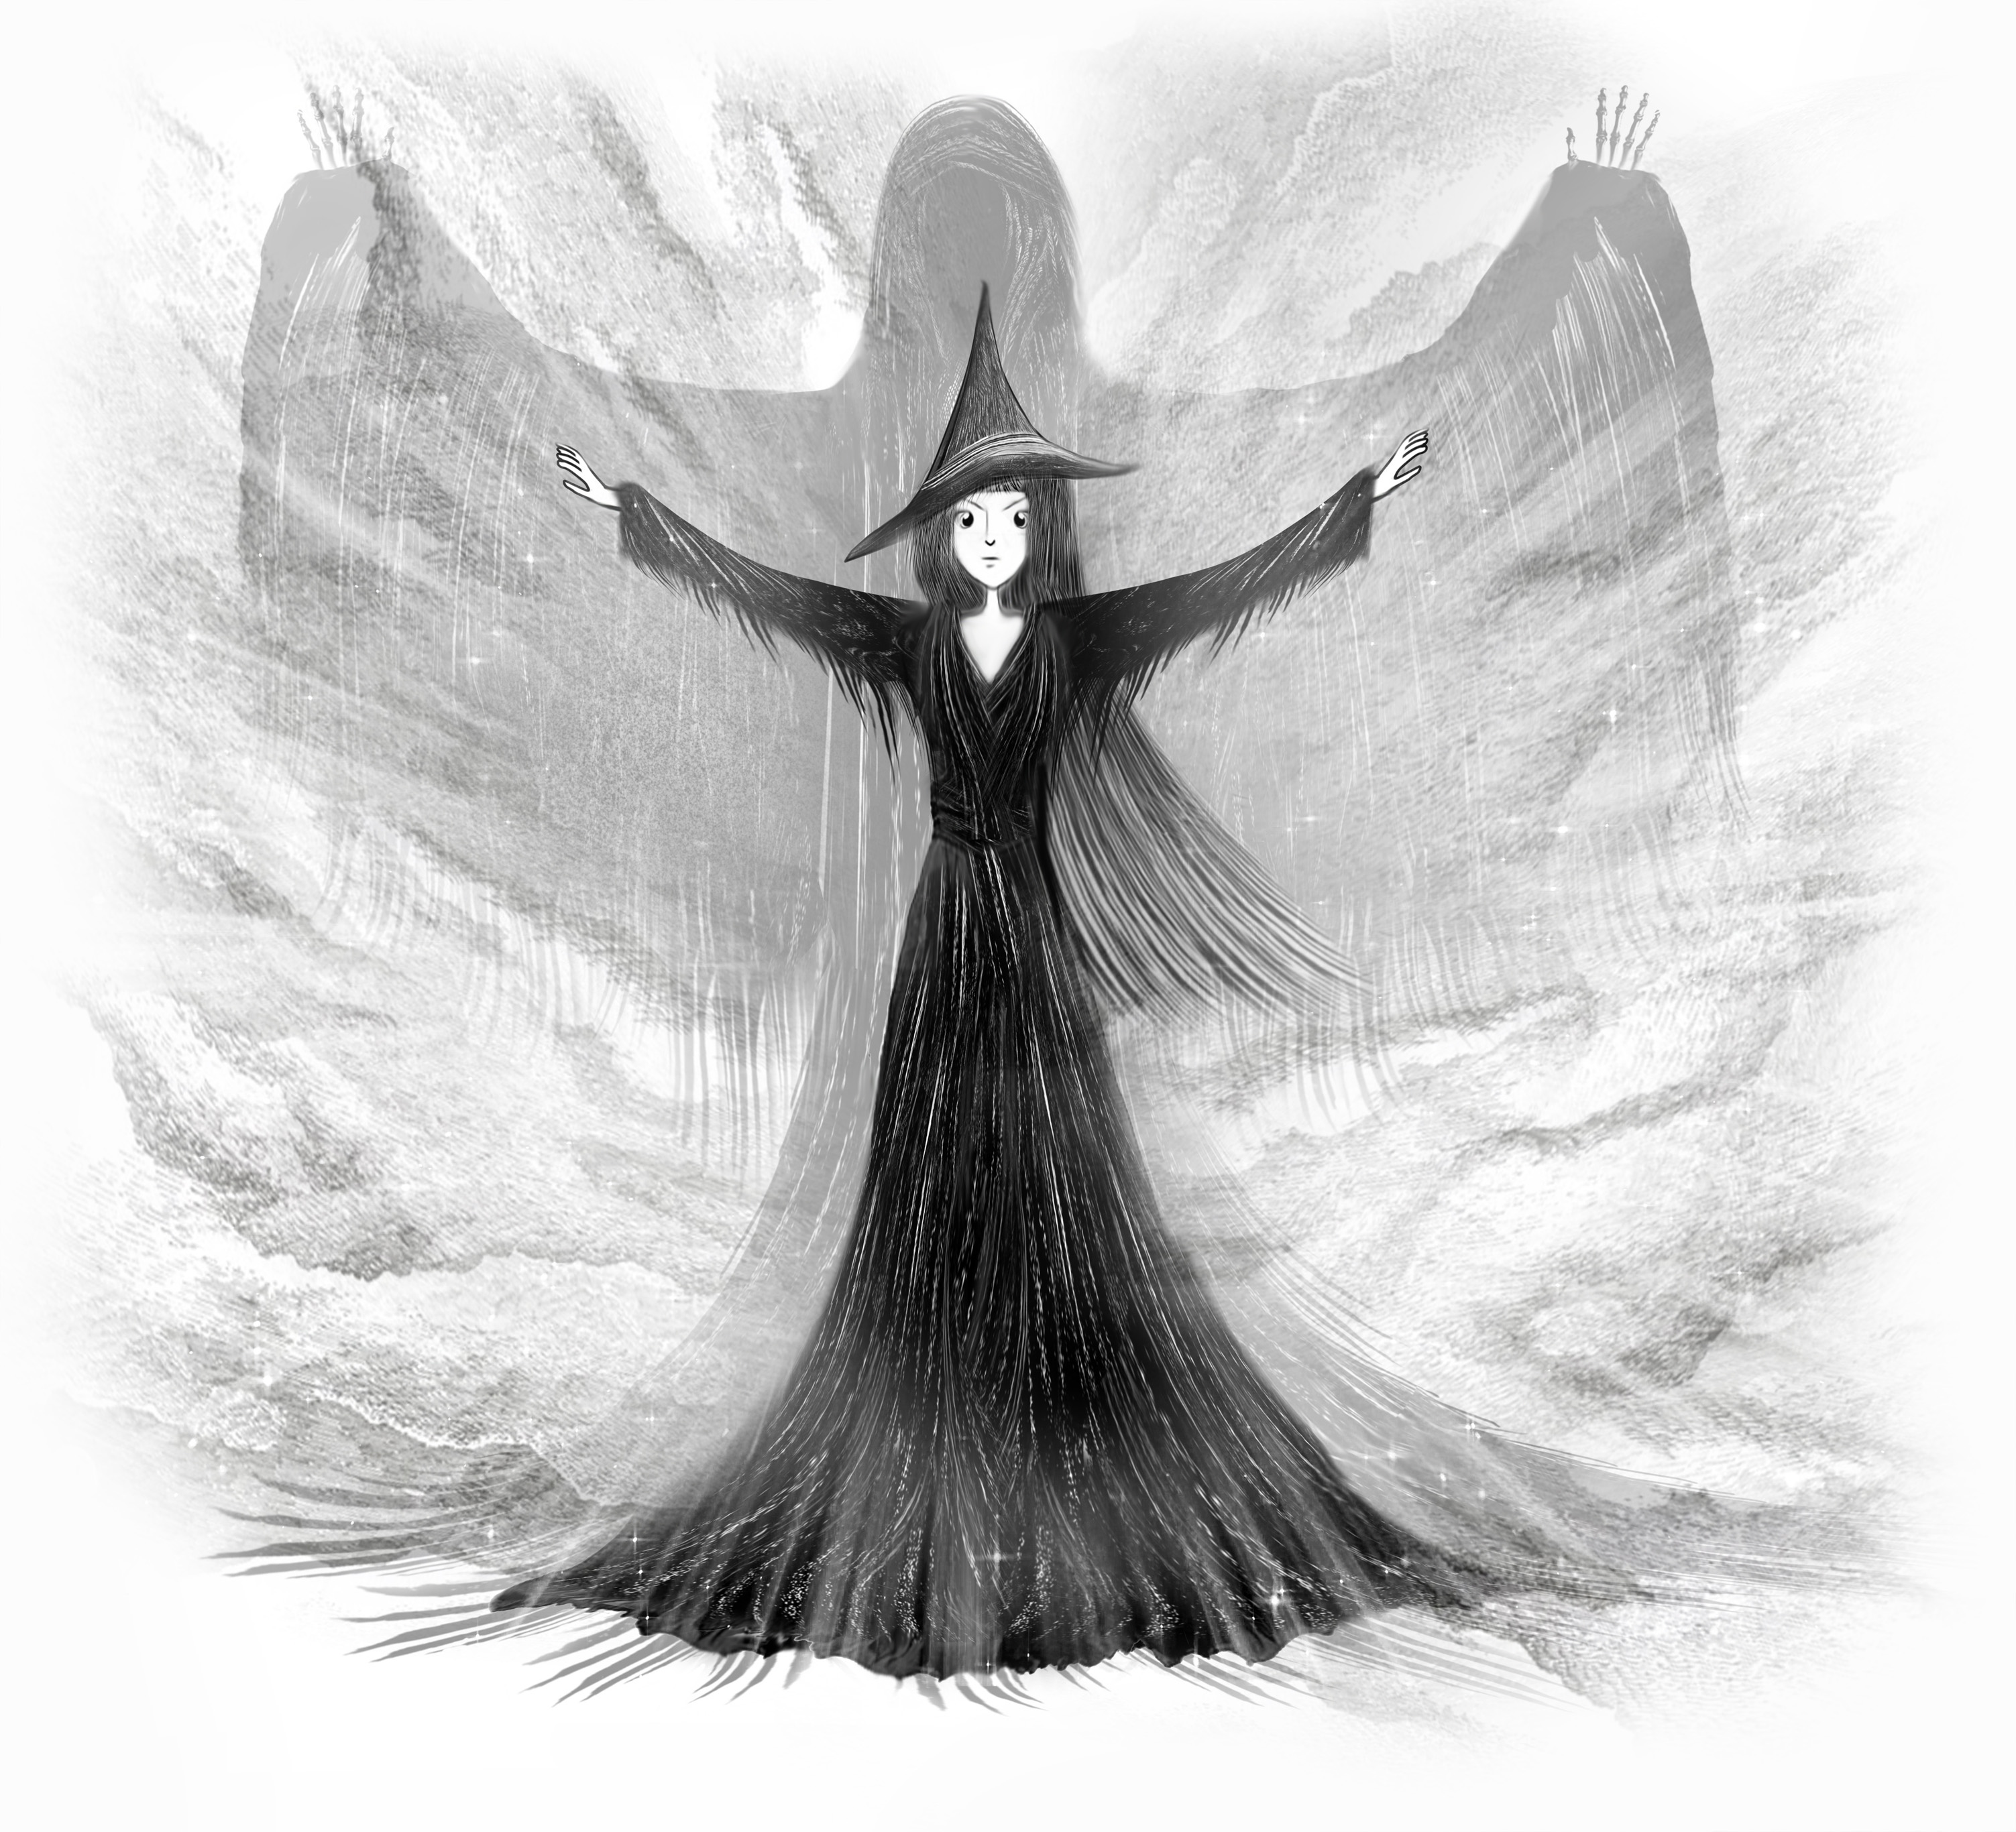
- Characterisation

Character study: Work with your reading partner to compare how the author describes the ‘good witches’ and the ‘evil witches’. Find evidence from Chapter 1 to complete the character mind map.

For e.g. Evil witches
e.g. Mogdred – sounds
like the word ‘dread’

Descriptions of appearances Character names

Lizzie/Bessie/Isla – normal

Characterisation
Descriptions of what they say
And how they say it. Descriptions of body Other examples language/actions

- After reading:
Discuss techniques/tools used by the author to create the characters in Chapter 1.

Chapter 2 - The Ring
- The author uses similes to help us visualise the setting, describe the action and to bring the characters to life in our imagination. With a partner skim Chapter 2 to provide at least 4 interesting similes.
e.g. ‘the spell shot out …and went right over her head like a thunderbolt’ (page 17)

- List the names of the evil witches. With your reading partner/trio discuss why you think the author chose these particular names for the witches. How do the names effect how you visualise each of the characters? (If children do not use the term stereotype during their discussion– teacher explains that it is a literary technique used by authors to create interesting characters)

- Word study – List the powerful verbs which the author uses instead of “said”: e.g. grunted, snorted, howled, murmured, bellowed

- List five powerful verbs used by the author to describe how the characters move. For e.g. hurtled, launched etc.

- Re-read the description of the Tree Trolls and create a drawing of how you visualise the two characters. (Advise pupils to use decoding strategies to discuss the meaning of the word ‘bulbous’.)

Reading into Writing

Focus: Characterisation

- Discuss with your reading partner/trio, the techniques authors use to create interesting characters. (Advise children that these techniques will form the success criteria which they will use to create their own characters)
For e.g. – Using stereotypical names
- Describing the character’s appearance/body language/speech/actions etc
- Using similes
- Using powerful verbs
- Setting

Chapter 3 - The Good Witches

- Word Finder: Use your word attack strategies to write your own definition of the following words:
Word | Definition
buzzard (page 20) | a type of bird
aroma (Page 20) | smell
wafting (Page 20) | drifting/floating upwards

Grammar & Punctuation Focus: Parts of Speech

- Write out the poem at the beginning of chapter 3, underlining the nouns in green and the verbs in blue. If you spot any adjectives, underline them in red.
Close Reading

Remind children that they will scan the text for specific words or phrases which appear in the question. They should refer to the text in order to fully answer each question. Advise against trying to recall the information from memory.

Before completing the task discuss different types of question: literal, inferential and evaluative, as well as the different approaches used to effectively answer each of these. Some questions may be a combination of these categories. Children should give reasons to support answers to evaluative and inferential questions.

- How old are Isla and Bessie? Isla is 150 years old and Bessie is 122 years old.
- What is strange about the witches, given their age? They both look pretty young.
- What age can a witch live to? A witch can live to 200 years old.
- What is affected as they get older? As witches age their height is affected, they shrink.
- Why do you think the author chose the name ‘Scoffalicious Chocolate’? Discuss how the author has combined the word scoff and delicious.
- What is so special about the chocolate? It tastes just like the favourite food of the person eating it.
- Who was Auntie Isla making the chocolate for? Isla was making the food for King Rohan, king of the Deer Folk.
- What is Bessie’s companion called? Bessie’s companion is a little bat called Podi.
- What is unusual about him? He lives under Bessie’s hat and doesn’t like to fly.
- What do you think caused him to become stuck on the beach? He was covered in goo which might have come from an oil spill or chemicals/litter in the sea. Link to pupil’s prior knowledge, relating to causes of water pollution which are harmful to wildlife.
- Why was Bessie considered to be an ‘unconventional’ witch? She never wore shoes and instead of a cat she had a little bat.
- Why does Thumble Tumble offer to deliver the Scoffalicious Chocolate to the Great Games? It is part of her plan to attend the Great Games.
- From reading chapter 3 use two words to describe Thumble Tumble. Give reasons for your answer. She is adventurous and quite smart for coming up with the plan to visit the games. She might be a bit mischievous because she is trying to fool her aunties in order to sneak into the games.
- Create 3 questions about the text for your partner/trio. Label each question as: Literal, Inferential or Evaluative. Remember some questions may be both inferential and evaluative.
- Create your own magical chocolate bar. What is it called? Is it delicious or horrible? Describe what it tastes like, using a range of interesting adjectives and similes.

Reading into Writing

Focus: Setting

- With your partner/trio, you will discuss the tools and techniques used by the author to describe the cottage and its setting. Has the author helped you to visualise the scene? Scan the text to give examples to support your answer.

Encourage children to use Higher Order Thinking Skills to UNDERSTAND, EVALUATE AND ANALYSE the techniques or tools used by the author to effectively create a setting.

Illicit discussion relating to how authors create an effective setting e.g. using similes, metaphors, descriptions of colour, light, weather, time of day, using the five senses – In the next chapter children will be asked to find evidence of these literary techniques. – This can form the basis of a ‘Reading into Writing’ task which will require children to create their own setting description

- Authors create setting descriptions using the five senses. Use the setting descriptions in Chapter 3 to give at least one example for each category in the table below:

Senses | Examples from the text
hear | e.g. Podi squealing
see | e.g The smoke looked like blue shoelaces as it crept back down the chimney and began twisting and spiralling through the kitchen.
smell
touch/feel
taste

Chapter 4 - Lochs, Castles and Rumours

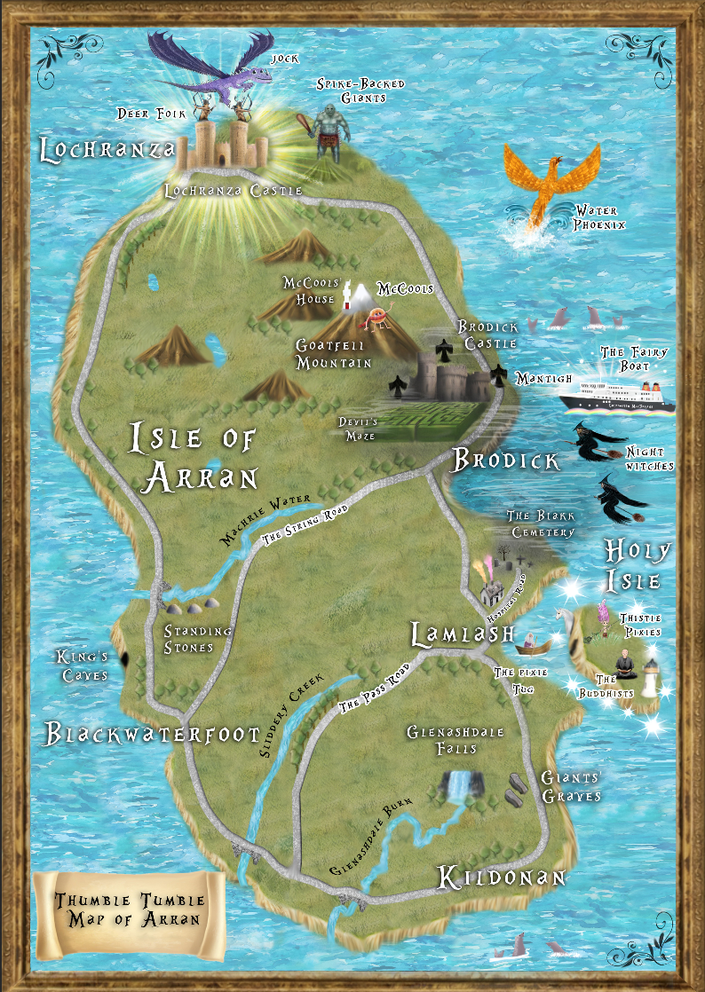
1. Using the ‘Magical Map’ of Arran find the grid references for the following places:

- Lochranza Castle
- Glenashdale Falls
- Blakk Cemetery

2. Draw a compass in Grid Reference G10

This Photo by Unknown Author is licensed under CC BY-SA

3. Thumble Tumble’s house is in grid reference F7. What direction would she fly from her house to get to the following places:

- Lochranza Castle
- The Kings Caves
- Glenashdale Falls

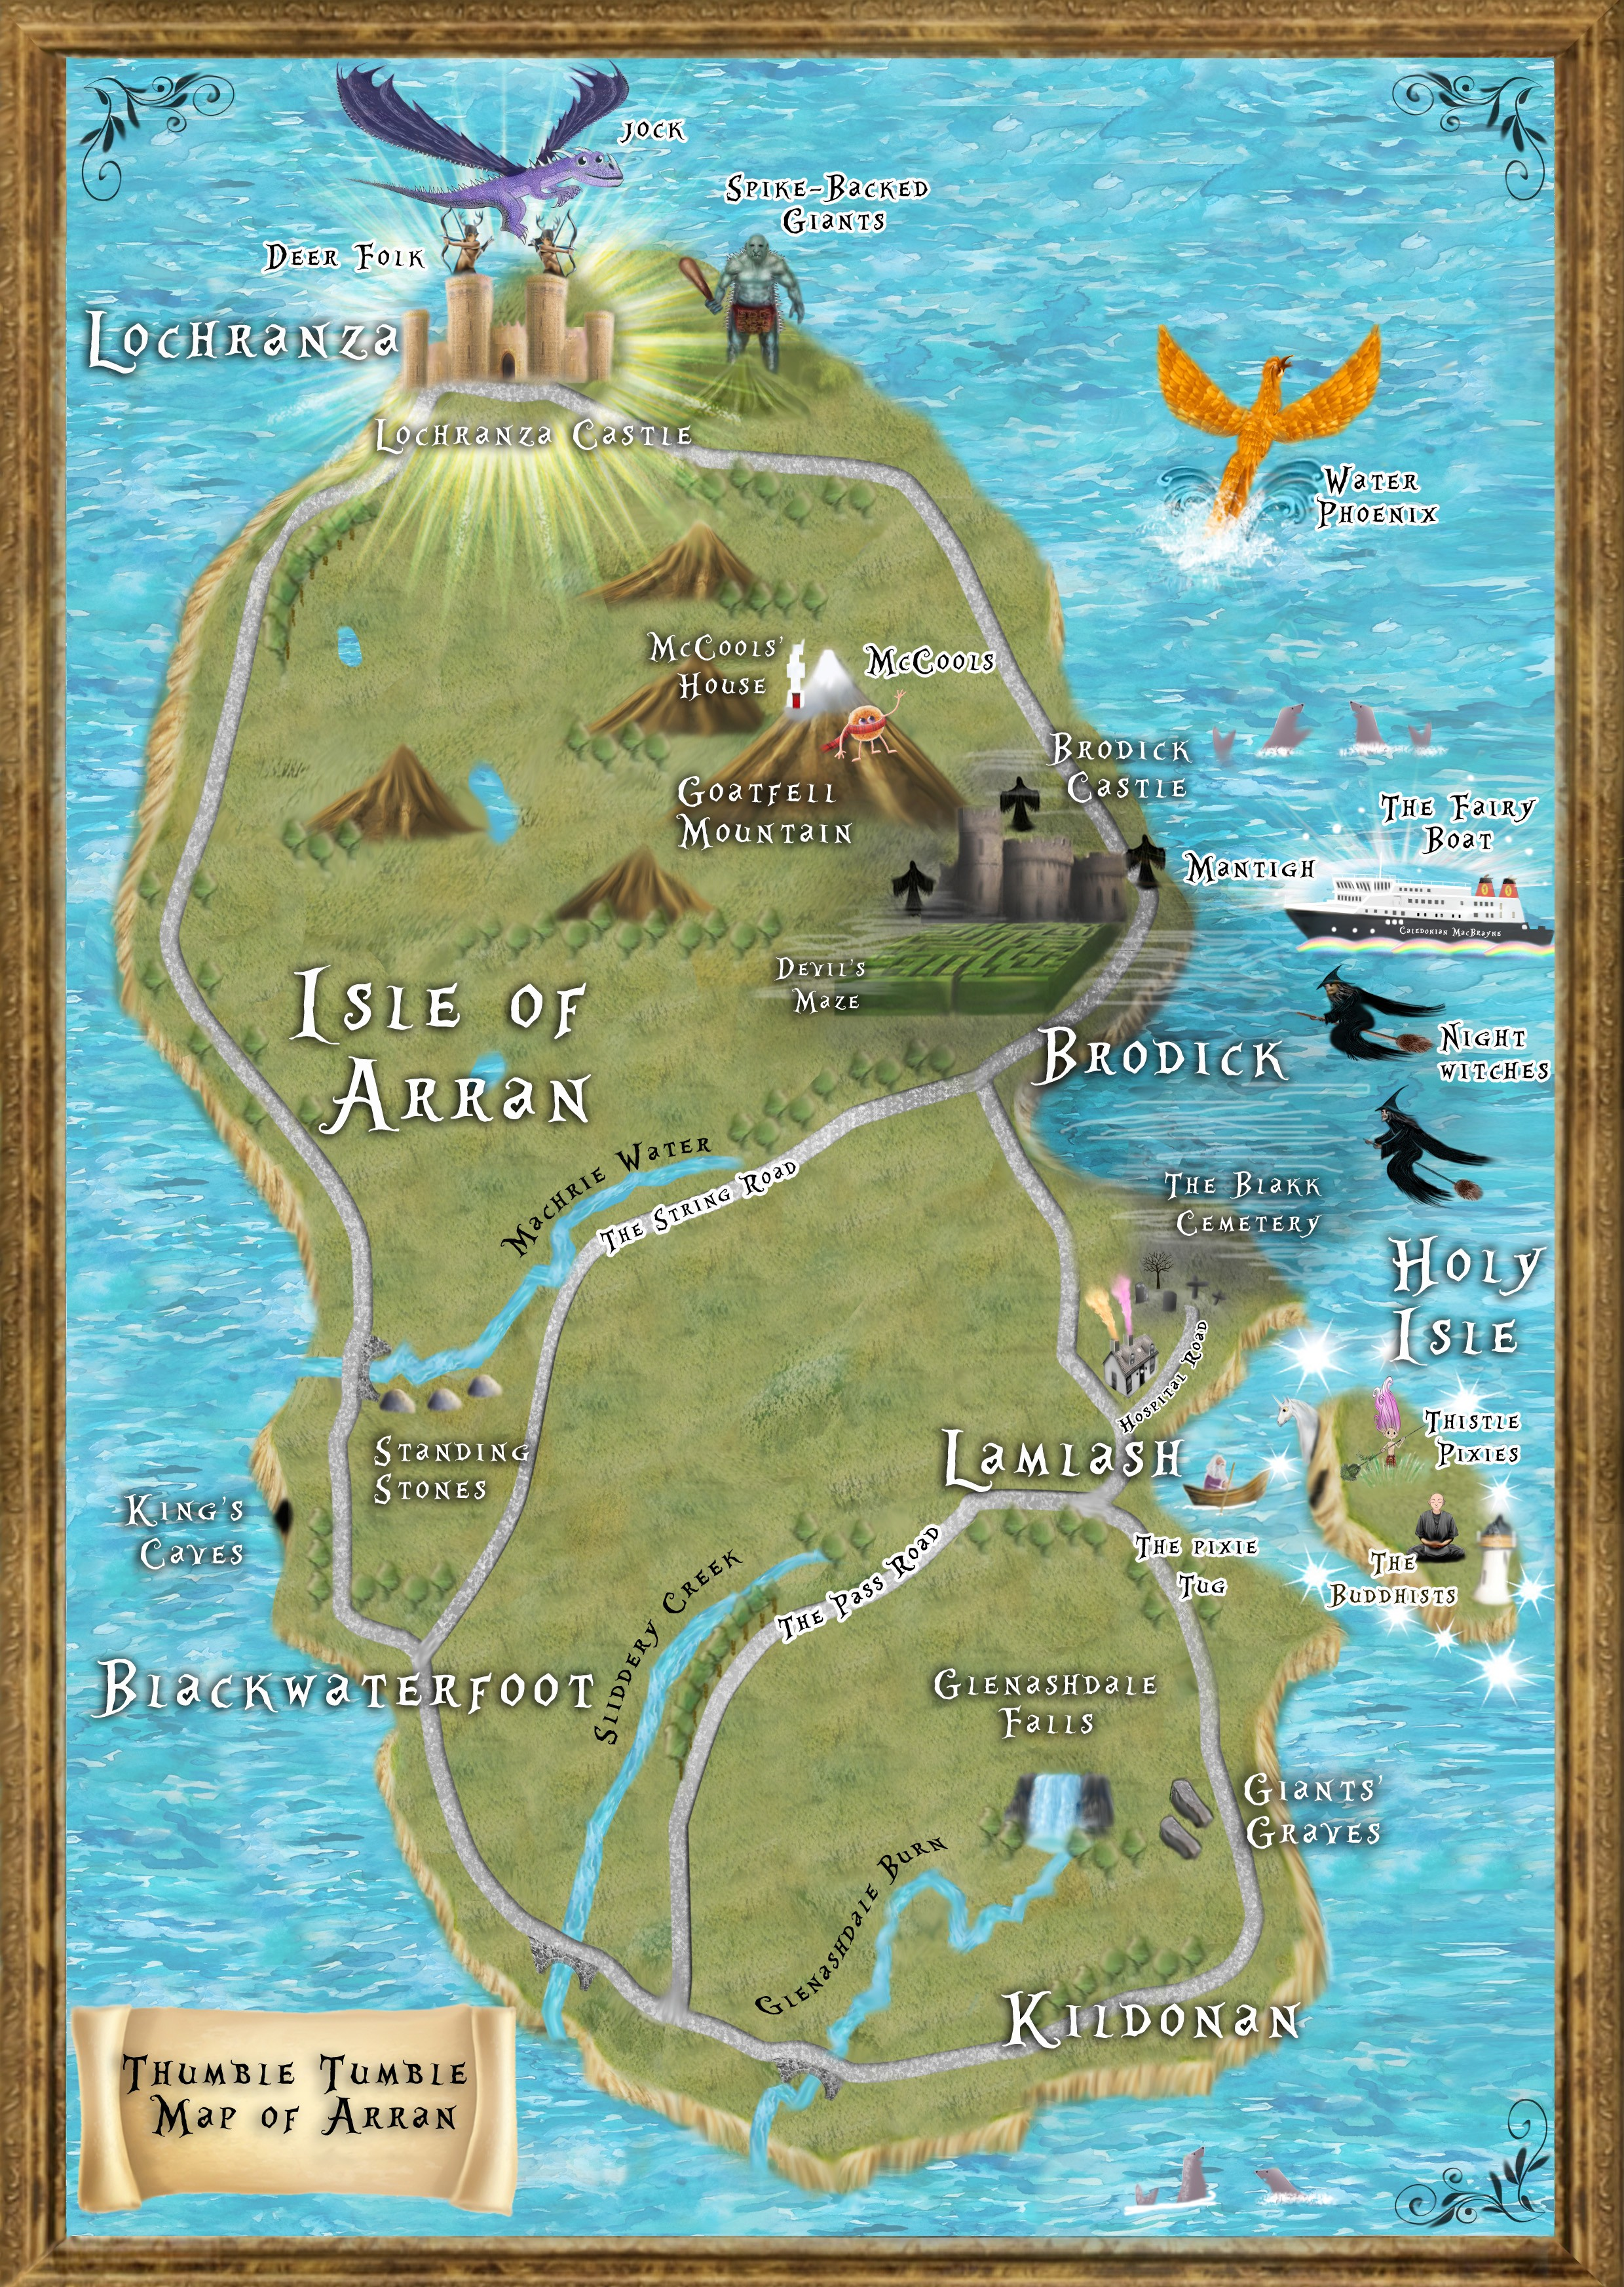
 | A | B | C | D | E | F | G | H
1
2
3
4
5
6
7
8
9
10

- Use your word attack strategies to write your own definition of the following words:

Word | Definition
detected - page 30 | e.g discovered
fiendish - page 30 | e.g evil
ingenious - page 32 | e.g. exceptionally clever
venom - page 33 | e.g. poisonous substance

Grammar and Punctuation – Similes
- Write out the last paragraph on page 33. Underline the similes.
Literacy Circle
(Suggestions for discussion – reinforce the idea that the children are using Higher Order Thinking Skills – understanding, evaluating and analysing, to critically discuss the text.)
.
After listening to the teacher reading chapter 4 discuss the following questions with your reading partner/trio:

- Why do you think the author chose the title, ‘Lochs, Castles and Rumours’? Refer to the setting descriptions of the loch and the castle. Discuss the rumours relating to the Deer People and the OlIpheist.
- Why is it difficult to work out if the story is set in olden or modern times? On one hand the story seems to be set in medieval times due to descriptions of castles and kings. However, some children may point out that Thumble Tumble is wearing ‘Converse’ trainers which may suggest that it is set in modern times.
- Evaluate how the author has described the castle and the setting. Has her description helped you create a vivid picture of it in your mind as you read? Points of discussion should relate to the setting focus in the previous chapter – pupils are identifying authorial techniques.
- Look at the illustration on page 33, discuss what is in the picture. Is it scary? Explain why?
- Look at each question above and discuss if they are literal, inferential, evaluative. (Some questions can be evaluative and inferential)
- Predict what will happen next in the story. Using evidence from the text to support predictions. (e.g. will the Ollpheist actually be as scary as suggested or is that just a ‘rumour’.

- Listening Activity:

Write a short description of what you think the fifth head of the Ollpheist could look like. Read your description to your partner/trio. They will make a drawing of the head by listening to your description. Include details of size, colour, number of eyes/ears/claws etc. Has your partner included all the correct details in their drawing?

Chapter 5 – Rhino Dust
Reading into Writing

- Scan page 37, paragraph 3, from ‘as their name suggests’. List the adjectives and similes which the author uses to describe the Spike Backs.

Writing Focus: Characterisation

- Throughout the book the author has used a variety of techniques to create imaginative and memorable characters. With your partner/trio you will brainstorm the techniques and tools which the author has used in the text, from the beginning of the book.

Their responses will form the success criteria for creating an imaginative character. Have the children refer back to the success criteria they came up with after reading chapter 2. Explain that they are APPLYING what they have learned from the author. (Higher Order Thinking skills: Understanding, Evaluating, Analysing and Application)

- Writing Activity: Create your own type of giant

Children will be using the same techniques used by the author to create a lively and memorable character description. When finished they will read their description to their partner/trio who will use the success criteria to peer assess their writing. Remind children that a successful character description should help the reader/listener to clearly visualise the character.

- Summary of Events

Create a flow chart, giving a brief description of events which lead to Thumble Tumble landing on top of the Ollpheist’s head.

START

Chapter 6 – Let the Games Begin
Word Study

- Use your word attack strategies to come up with synonyms for the words in the table:
Word | Synonym
arrogant - page 41 | e.g. conceited
extremely - page 42 | very
lobbed - page 42 | threw
hollered - page 45 | shouted

- Describe your first impressions of MJ. Give evidence from the text to support your answer.

- Compare and contrast the Deer Folk from each of the different islands.
Island | Deer Folk Description
Eigg | Only a few feet tall
Islay | The tallest of the Deer Folk
Muck | Absolutely filthy
Rum | Tipsy

- Give two examples of how the author uses ‘stereotype’ to help the reader visualise the different characters. e.g. The Deer Folk FROM Muck were described as absolutely filthy, one of the big characters is called Bruiser.

- Who do you think would be a better class mate: MJ or Serena? Give reasons for your answer.

- Why are the Deer Folk from Islay known as the ‘big yins’? Explain your understanding of the phrase. Explain that this is an example Scots language – can they give other examples.

- Bruiser’s arms were described as being ‘as thick as a tree’. Write your own simile to describe one of the characters from Chapter 6.

- The Lochranza flag is split into four sections, each with an illustration that has something to do with the Lochranza Castle. Think of where you live/or where your school is and design a flag with four images on it. Each image is to represent something about your home/school. Present your flag to the class/partner/trio and describe what is in each section, giving an explanation as to why you have chosen each of the images.

Reading into Writing

With your partner/trio, re-read the description of the final of the Tug-O-War.
Teacher reads the description aloud – discuss how the description sounds like a radio sports commentary. Dicuss the features of this genre to form the success criteria for the writing task below.

Digital Text

Work with your partner/trio to create and record your own ‘sports commentary’ of the final of the ‘Tug-O-War’. However, your commentary will present a very different chain of events, with your own alternative ending.
Talking and Listening; Before recording, children could be given the opportunity to listen to a sports commentator – followed by a discussion about how the presenter engages the interest of the listener - how they vary the pitch, tone and pace of their speech to make the description exciting.

Chapter 7 – The Secret of the Ollpheist

Reading into Writing – Legends

Discussion: Re-read the Ollpheist’s recount of how he became the ‘legend of the Ollpheist’ on page 51. Can you think of any similar legends?

Teacher can read an example of a Scottish Legend which involves a mythical creature.

List the features of a legend

Inform children that these will form the success criteria for the Legend which they will create.

Chapter 8 – Spoilsports
Reading into Writing

Focus of the lesson is to help the children identify the tools the author uses to build tension and create atmosphere. Explain that they will use these tools when writing their story of a mythical creature.

Discussion Before reading Chapter 8:

- Re-read the last paragraph of Chapter 7 on page 53. What tool does the author use to suggest that something awful is about to happen? Make a prediction about what will happen next?

Discussion After Reading Chapter 8:

- Reflect on your prediction. Were you correct?

- Scan the first paragraph. Explain why the author has used italics.

- If the author had written, ‘MJ was still in the changing room when he realised they were under attack from the Night Witches’. Discuss how this shortened version lacks details. Which version would readers prefer?

- Now scan the rest of page 54. Discuss the author’s use of imagery.

- Identify how the author creates a feeling of chaos in the arena above MJ

Writing a Legend

Use success criteria and the ‘Story Mountain’ planning sheet to write your own Scottish legend about mythical creature.

The Story Mountain planning sheets will assist the children in structuring their text. Remind children to use the literary techniques which they have learned from the author to create imaginative characters and vivid settings.

Story Mountain for: ____The Legend of_________________________________________ Name: ________________________________
Problem
________________________________________________________________________________________________________________________________________
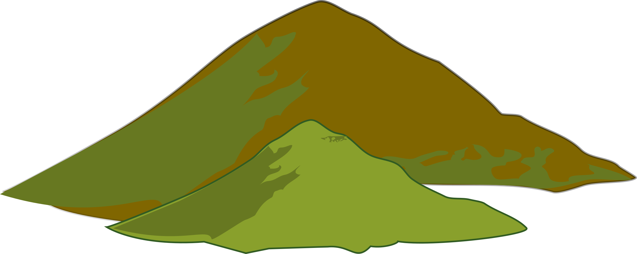
Story Mountain
Build Up
________________________________________________________________________________________________________________________________________
Characters

Settings

Resolution
________________________________________________________________________________________________________________________________________
Ending
________________________________________________________________________________________________________________________________________
Introduction
________________________________________________________________________________________________________________________________________

TRUE, FALSE, JUSTIFY

Tick the statements below as being True or False. Justify your answers to your partner/trio by using evidence from the text.

Statement | True | False
MJ wasn't that bothered about being beaten by a girl |  | x
MJ was used to hearing actual screams of fear |  | x
Thunder bolts leave a circle of black powder? | x
The Deer Folk were under attack from Spike Back Giants |  | x
MJ Waived his arms to draw the Night Witches away from the panicked crowds |  | x
MJ was arrogant | x
Serena appeared out of nowhere with a spare bow for MJ |  | x
Night Witches stay within the dark clouds when fighting | x
Serena hit four Night Witches sending them spinning out of control |  | x
Mac's blood poured onto the arena floor when he was hit on the shoulder | x
A bolt singed MJ's fingers before hitting Mac on the leg just below the knee |  | x
MJ shouted to Serena to get Geeza out of the arena |  | x
Serena stabbed Geeza in the back with an arrow | x
MJ was like a raging bull, charging at the Night Witches after his two friends were injured | x

Chapter 9 – Melting Pot

Word Study

- Scan page 59 from “Thank goodness they’ve gone” to the end of page 60. List the ten contractions on the pages in order of appearance

- Choose any 3 contractions and use them in a short paragraph to describe what you think happens next.

- Read the remainder of the chapter and discuss/compare with your partner/trio what ‘actually’ happened next. Compare with your prediction

- Scan page 63. Use your word attack strategies to interpret what the following words mean:

- glee
- chant
- summoned
- disintegrated
- charred

- Write a short paragraph about witches that includes at least three of the above words

Chapter 10 - Snatched

Alfy was having so much fun playing with the ‘Snozel Frazens’ that she had tears streaming down her face.

1. Create your own ‘mini beast’. Describe what it would do to make you laugh.

2. Draw your mini beast here:

Close Reading

- Who saved Alfy and why?
- Describe how Alfy managed to find herself in a sinking swamp
- Write down the definition of the word ‘guest’
- In the chapter the author puts the word ‘guest’ in italics when Mogdred says “Alfy will remain a ‘guest’ forever”. Explain why the author has used italics when Mogdred says this with reference to what Mogdred really means by the word ‘guest’

Chapter 11 – Lazlo’s Cup
- Read page 68 only, then predict why Thumble Tumble feels like she has met Mac, MJ and Geeza before?
Continue reading the remainder of the chapter and answer the questions below.
- Why do you think MJ decided not to join in the games? e.g. He has become more mature and is no longer obsessed with winning/he has already proven his bravery and skills.
- Describe how MJ’s character changed throughout the story. Use the table below to give examples of how he has changed.
MJ’s Character Transformation
Chapter 6 | Chapter 8 – Chapter 11

- What do you think was the turning point for MJ’s transformation? The turning point came when MJ had to defend his friends and family from the Dark Witches.
- Give an example of other books you have read, or films you have watched which include a character turning point, or transformation. e.g. A Christmas Carol – Scrooge
- What does the author mean when she uses the phrase, ‘Looks can be deceiving’ when referring to the Lazlo Cup? Despite being quite small and rusty in appearance, the cup is actually very powerful.
- Thumble Tumble’s aunts use a ‘Pausing Spell’ so that they can enter the royal box during the Great Games. Devise a spell that would allow you to enter the Great Games. Give your spell a magical name and describe what it does.

Chapter 12 – The Return of the Protector
- Summarise how the book ends.

- Write an alternative ending to the book where it does not end in a cliffhanger.

- Create an online Blog or Vlog to review the book on your school website.

Curricular Links

Literacy | Experiences & Outcomes | I can:
Talking & Listening | Understanding, analysing and evaluating  I can show my understanding of what I listen to or watch by responding to literal, inferential, evaluative and other types of questions, and by asking different kinds of questions of my own.  LIT 2-07a  I can recognise how the features of spoken language can help in communication and I can use what I learn. I can recognise different features of my own and others’ spoken language.  ENG 2-03a | respond to a range of questions, including literal, inferential and evaluative questions, to demonstrate understanding of spoken texts.  Applies verbal and non-verbal techniques in oral presentations and interactions, for example, vocabulary, eye contact, body language, emphasis, pace and/or tone.  Recognises some techniques used to engage or influence the listener, for example, vocabulary, emphasis, tone and/or rhetorical questions.
Reading | Tools for Reading  Through developing my knowledge of context clues, punctuation, grammar and layout, I can read unfamiliar texts with increasing fluency, understanding and expression.  ENG 2-12a  I can select and use a range of strategies and resources before I read, and as I read, to help make the meaning of texts clear.  LIT 2-13a | Use knowledge of context clues, punctuation, grammar and layout to read unfamiliar texts with understanding.  Apply a range of reading skills and strategies to read and understand texts, for example, skimming, scanning, predicting, clarifying and/or summarising.
Reading | Understanding, analysing and evaluating  To show my understanding across different areas of learning, I can identify and consider the purpose and main ideas of a text and use supporting detail.  LIT 2-16a  To show my understanding, I can respond to literal, inferential and evaluative questions and other close reading tasks and can create different kinds of questions of my own.  ENG 2-17a  I discuss structure, characterisation and/or setting; recognise the relevance of the writer’s theme and how this relates to my own and others’ experiences; discuss the writer’s style and other features appropriate to the genre  ENG 2-19a | Make relevant comments about features of language, for example, vocabulary, sentence structure and punctuation.  Respond to a range of questions, including literal, inferential and evaluative questions, to demonstrate understanding of texts.  Make relevant comments about characterisation with reference to the text.  Make relevant comments about aspects of the writer’s style, use of language and other features appropriate to genre, with reference to the text.
Writing | Creating Texts  Having explored the elements which writers use in different genres, I can use what I learn to create stories, poems and plays with an interesting and appropriate structure, interesting characters and/or settings which come to life.  ENG 2-31a | When writing imaginatively and creatively, I can:  -Apply a few features of the chosen genre.  -Create interesting characters through, for example, their feelings and actions, physical description and/or dialogue.  -Attempt to use figurative language (imagery) to engage the reader, for example, simile, metaphor, alliteration and onomatopoeia.  -Create plots with clear structures, for example, suitable opening, turning point, climax and/or satisfactory ending.

