A Novel Study

Thumble Tumble and the Cauldron of Undry

By A.H. Proctor

Teacher’s Pack

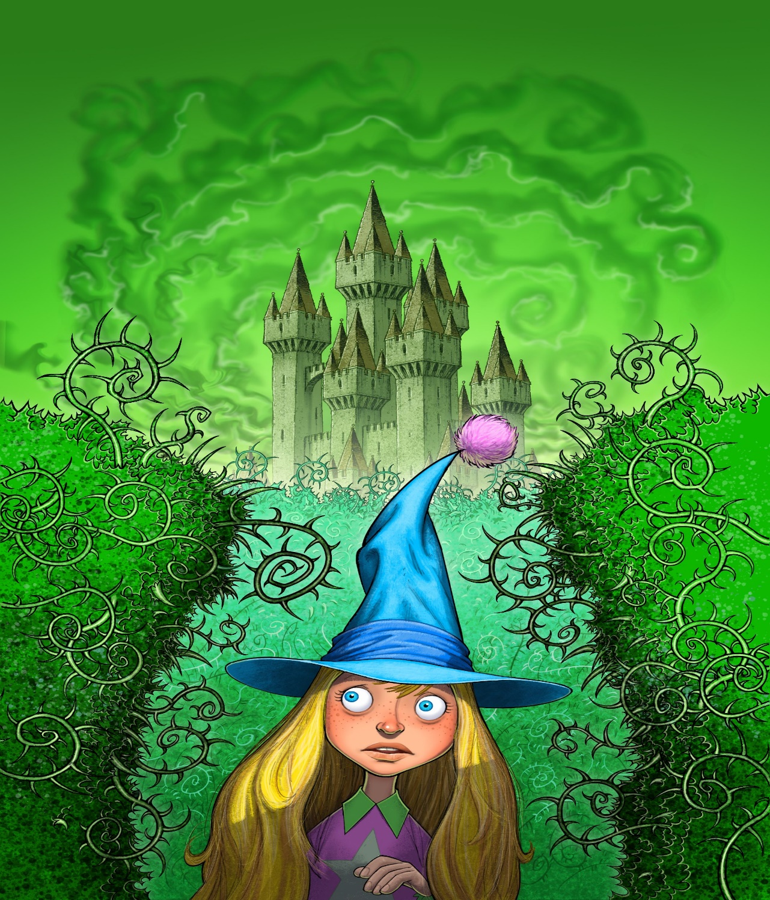

Teaching Pack

- Improving vocabulary is a major focus of the pack. Pre-read the text to identify vocabulary which might be unfamiliar to the learners. Pre-teach 1-2 words from each chapter which you feel the learners can use when creating their own texts

- Pupils will also be supported in expanding their vocabulary and developing their ability to independently apply strategies when they come across new or unfamiliar vocabulary.

- Teachers will explicitly teach the ‘Before, During and After Reading Strategies’ with a view to developing learners’ ability to apply them independently; thus improving their ability to comprehend new and more complex texts in the future.

- The ‘Before, During and After Reading Strategies’ can also be used to support learners’ ability to identify different authorial techniques, relating to characterisation, setting and plot, as well as their ability to apply these when creating texts of their own. The pack contains suggested activities and approaches to ‘Reading into Writing’ .

- To encourage reading for enjoyment. It is not advisable to complete every suggested activity and time should be used to simply read to the children.

- The pack also provides some suggestions about using the novel to relate to other areas of the curriculum.

Curriculum for Excellence

Experience & Outcome | Learning Focus
Talking and Listening
Understanding, analysing & evaluating  LIT 2-07a | Listening & responding to literal, inferential, evaluative questions and creating questions
Creating Texts  LIT 2-10a / LIT 3-10a | Communicating with others in a clear and expressive way.
Reading
Tools for Reading  LIT 2-13a | Asking questions before and during reading  Making predictions before and during reading
Tools for Reading  ENG 2-12a | Using a range of strategies to support comprehension: syntax, visual clues & semantics.
Understanding, Analysing & Evaluating  LIT 2-16a | Identifying and discussing the writer’s themes
Finding & Using Information  LIT 2-14a | Identify and discussing the features of a text
Writing
Organising & Using Information  LIT 2-25A  LIT 2-26a | Developing ideas to create new texts (fiction & non-fiction).
Creating Texts  LIT 2-28a | Applying elements authors use to create texts  Applying new vocabulary when creating texts

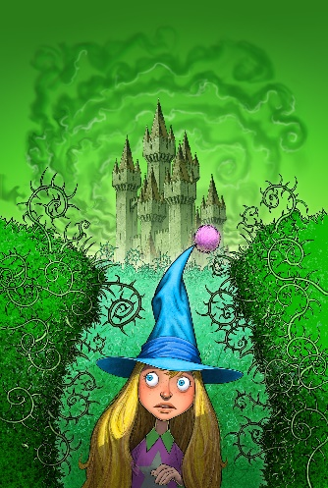

Before Reading – Book Wizard Strategies

Book Wizards ask questions and look for clues before opening the book!

Discuss the following questions with your reading partner:

- Is it a fiction or non-fiction text?
- What is the genre of the text?
- What can I predict from the title, the picture, the blurb and the author?
- What can I visualise from the title?
- Have I read similar texts?
- What am I looking forward to finding out about the characters/plot/setting?

During Reading – Book Wizard Strategies

During reading Book Wizards:

- Visualise the characters, setting and action

- Ask questions about the text

- Identify themes from the text

- Check for main ideas

- Sometimes make notes or highlight new vocabulary and interesting phrases

- Use decoding strategies to help them read new vocabulary

- Use a variety of strategies to help them to understand the meaning of new words (‘Word Wizard Strategies’ & ’Word Wizard Dictionary’)

- Re-read certain parts to help their understanding of the text

- Look out for important punctuation

After Reading Strategies

After reading Book Wizards:
- Make predictions using clues from the text

- Discuss the text with other Book Wizards - ask and answer questions and make predictions

- Discuss and compare opinions on techniques used by the author to create characters, setting and plot

- Re-read part of the text – highlighting key ideas and discussing their understanding of new vocabulary

- Consider how they might use the author’s techniques and new vocabulary in their own writing

- Summarise the main events and important information

Before Reading

Thinking Routine - ‘I See, I Think, I Wonder’. Look closely at the illustration on the cover (Teacher will provide a picture of the cover with the blurb and title removed. Children will use the template below.)

LI: I can use evidence from the cover, before reading, to make predictions and ask questions about the characters, setting and plot

I see | I think | I wonder
e.g. I see a girl on the cover | I think she is a witch and. I think she will be the main character | I wonder why she looks frightened

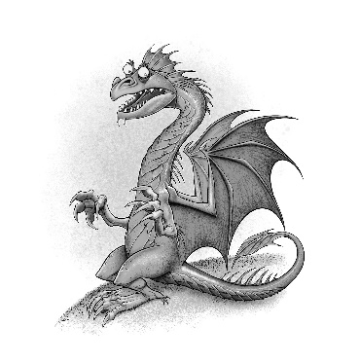

Chapter 1 - And Then There Was One

LI: I can use evidence from the text to make predictions.

Teacher reveals the title and blurb, then reads the first chapter; The Learners make predictions, supported by evidence from the text.

Magical Predictions!

Prediction | Evidence
E.g. The genre of the book is fantasy. | The first characters we come across are dragons and witches.

Chapter 1 - Word Wizards!

Think, Pair, Share.

Learning Intention: I am learning to use a variety of strategies to help me understand the meaning of new vocabulary

Learners work in pairs to locate and define the words below. They will share the strategies they used with their peers when finished.

(See Word Wizard Strategy List)

Word/Phrase | Page No. | Definition | Word Class | Prefix? | Suffix?
Luminous | 5 | Can be seen in the dark | Adjective (discuss that the word ends in ‘ous’, Lumin - word origin etc.)
Appetising | 5 |  |  | un
Ignite | 8 |  |  | re
Hideous | 9

Word Wizards add the words to their ‘Word Wizard Dictionary’ (See template for the dictionary)
Word Wizards will be advised that they can add to their dictionaries as they progress through the novel and all Wizards will look for opportunities to use their ‘Word Wizardry’ in their own writing. Teachers and peers can look out for ‘Wizard Words’ during teacher or peer assessment.

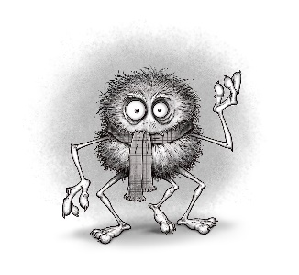Word Wizard Dictionary

Word | Definition | Word Class | Sentence
E.g. Hideous | Disgusting to look at/smell etc. | Adjective (clue ‘ous’) | Mogdred was a hideous witch!
 |  |  | Prefix | Suffix
Word | Definition | Word Class | Sentence
 |  |  | Prefix | Suffix
Word | Definition | Word Class | Sentence
 |  |  | Prefix | Suffix
Word | Definition | Word Class | Sentence
 |  |  | Prefix | Suffix
Word | Definition | Word Class | Sentence
 |  |  | Prefix | Suffix
Word | Definition | Word Class | Sentence
 |  |  | Prefix | Suffix
Word | Definition | Word Class | Sentence
 |  |  | Prefix | Suffix

Chapter 1 - Word Wizard Strategies

Strategies to help you become a wonderful Word Wizard!

When I am unsure of the meaning of a word I can:

- Stop and think about what I already know

- Study the word closely – the beginning, the middle & the end to look for grammar and punctuation
  - Do you know any similar words?
  - Can you make a smart guess about the origin of the word? For e.g. if it ends a vowel it might have an Italian origin, like spaghetti or pizza.
  - What class of word is it? Verb, Adverb, Noun, Adjective
  - Does it start with a capital? If so it is a Proper Noun, like someone’s name, for e.g. Thumble Tumble.
  - How does the word end – e.g. a word ending in ‘ous’ might suggest that it is an adjective, like marvellous or enormous, a word ending in ‘ed’ might be a verb, like walked or smiled.
  - Does it star with a prefix or end with a suffix.
  - Do you know the meaning of part of the word?

- Leave the word out and read forwards and backwards to the end of the sentence

- Read the sentences before and after the word

- Guess a synonym for the word, does it fit well into the sentence?

- Discuss the word with a partner

- If you are still unsure use a dictionary
Chapter 2 - The Three Legged Haggis

LI: I can answer literal, inferential and evaluative questions relating to a fictional text.

- Why did Morven go to McCools’ house if she’d never met him before?
Morven went to McCools’ house because he was reputed to be the wisest creature on Arran and therefore if anyone could help her it was him.
- Why might it have been difficult to find McCools’ house?
It would be difficult to find the house because the whole building was pure white so that it blended in with the snow-capped mountain.
- What speech do you think humans said before dining on Haggis?
I think that the humans would have said ‘An Ode to a Haggis’ by Rabbie Burns.
- Write a definition for Haggis and neaps for visitors to Scotland.
Haggis, neeps and tatties is a Scottish dish, traditionally eaten on Burns Night. Haggis is made from minced sheep pluck, mixed with spices and oats. Neeps is Scots for turnips and tatties is Scots for potatoes.
- Had Morven had ever seen a Haggis before she met McCools?
No, Morven had never seen a Haggis before because she thought, ‘So this is what a Haggis looks like’, when she saw McCools.
- What did McCools give Morven to make her feel better?
McCools gave Morven a green herb to help her calm down because she was in shock.
- Describe what Lizzie’s character might have been like. Give reasons for your answer.
I think that Lizzie was a brave and caring character because she died fighting the Night Witches and she was called The Protector.
- Use three adjectives to describe Morven’s character, using evidence from page 16.

Chapter 2 - Word Wizard Challenge

Think, Pair, Share.

Work in pairs/trios to locate and discuss the meanings of the words below. Add the highlighted word to you ‘Word Wizard Dictionary’.

LI: I am learning to apply a variety of strategies to support my understanding of new vocabulary

Word | Page no.
Recluse | 12
Pleaded | 13
Extinction | 14
Immense | 15
Morph | 16

.

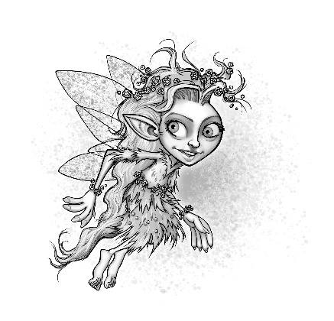

Chapter 3 - Breakfast at Devil’s Maze

Characterisation

Lily, Boris and Torgle all use a safe, children’s messaging app, called ‘WizAp’. Use evidence from the text to create an online profile for Lily
(Template for the app is in the children’s pack)

*Revisit online safety guidance – use of avatars instead of photographs, nicknames instead of real name etc.

Chapter 3 – Breakfast at the Devil’s Maze

Write 5 posts on ‘WizAp’ to describe the events of chapter 3 from the point of view of one of the characters (Lily, Boris or Torgle)
(The message template is provided)

For example:
Lily -
6.00am
I’m SOOOO excited, it’s my 96th birthday today!!!

Chapter 3 - Word Wizard Challenges

LI: I am learning to use a variety of strategies to help me understand new vocabulary

  - Word Wizard Challenge - Work in pairs or trios to discuss the definitions of the words belwo. Add the highlighted words to your Word Wizard Dictionary.

Word/Phrase | Page
Peculiar | 23
Mischievous | 24
Glistened | 25
Toxic | 26
Hybrid | 27

  - Word Wizard Challenge: Discuss what the idiom below means with your parter/trio.

Boris wasn’t the sharpest tack in the box.

Create an idiom which is the opposite of this.

Chapter 3 to 5 - Reading into Writing

LI: I can identify and discuss techniques and language used by authors to create and develop characters
Work with your partner/trio to find examples of the following:

Characterisation Technique | Examples from the text
Stereotypical name | E.g. Lily - sounds light and pretty
Colour
Setting
Alliteration
Adjectives & descriptive phrases
How the characters speak - words used/tone
How the characters’ move/body language/facial expression
Strengths/Weaknesses/Special Powers

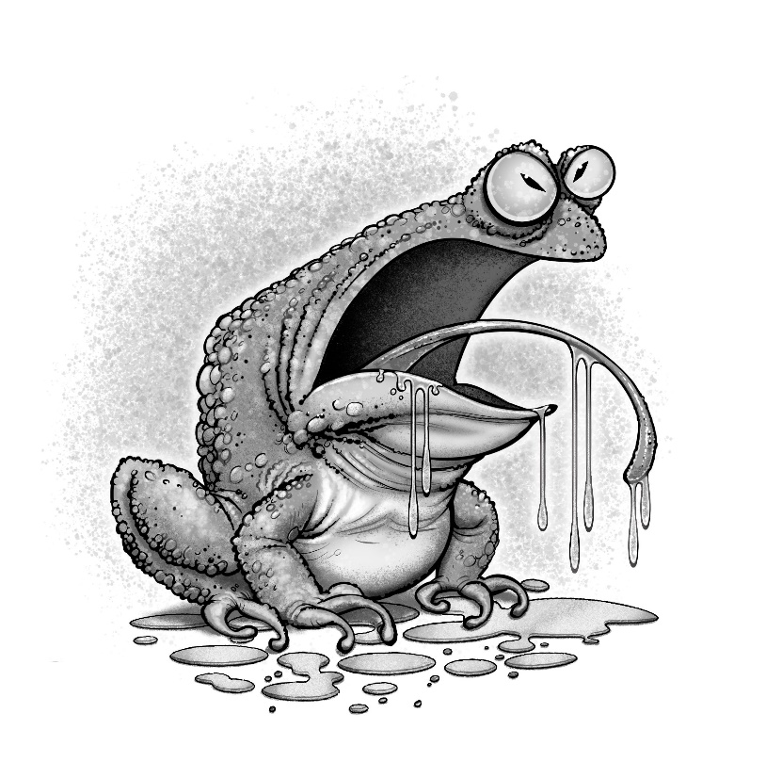

Chapter 3 to 5 – Writing & Creating a Character

LI: I can apply some of the techniques used by authors to create and develop characters of my own

Think, Pair, Share

Use the thinking routine to identify the techniques used by authors to create characters. Learners will use these as the success criteria to create their own magical character.

E.g
Setting - setting, colour
Stereotype - name, appearance
Actions
Body Language
Idioms
Similes
Speech - adverbs to describe how characters speak, powerful verbs (synonyms of said, e.g hollered)

Science, Technology, Engineering, Arts, Mathematics:

STEAM Challenge

LI: I am developing my design skills to solve problems

CHALLENGE

Create a model of a Flower Nymph which will ‘float’ and ‘spin’! (see page 21)

What problem do I need to solve?

Design the wings so that the model Nymph floats to the ground and avoids ‘splattering into the ground’!

What supplies will I use?

What is my plan?

What worked well?

What would I change to improve the design?

What have I learned from doing this challenge?

Chapter 4 – Loo Roll Confetti

Question Challenge

LI: I am learning to create a variety of different types of question

2.Question Challenge!

In pairs/trios, create three literal questions, two evaluative and one inferential question relating to Chapter 4.

LI: I can discuss the techniques and language used by an author to create tone or atmosphere

3. Humour – Scan the text and to find examples of how the author uses humour to entertain the reader. E.g. Names of the characters – Selfie. Name of the newspaper and gossip magazine.

Chapter 4 - Drama Challenge

LI: I am learning to adapt my voice, movement and expression to perform in role

Hot-seating in groups - children select peers to answer questions in role as: Jock, Thumble Tumble, Minx and Selfie

Chapter 4 - Reading into Writing

LI: I can identify and discuss the features of a magazine article

Re-read pages 34-36 – discuss the meaning of ‘paparazzi’ and the features of a ‘gossip magazine’. Engage Learners in discussion about the ‘reliability’ of celebrity gossip websites and magazines.

Writing – You are a Celebrity Reporter!

LI: I can write a magazine article

Create a column for your own gossip magazine - recounting the events between Lily, Serena and Torgle, using humour to entertain the reader.

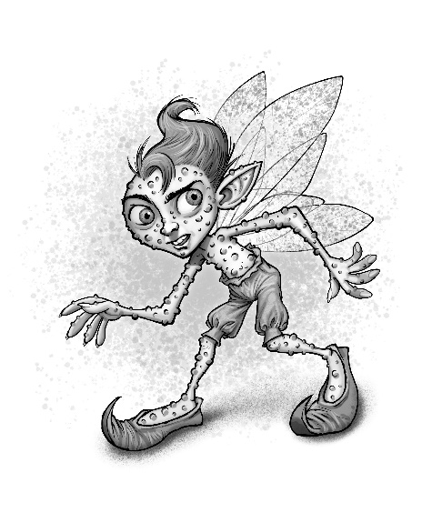

Chapter 5 – The Dark Witches’ Lair

Chapter 5 - Word Wizard Challenges

LI: I am learning to use a variety of strategies to support my understanding of new vocabulary

1.Work in trios/pairs to find synonyms from the text for the words in the table below

Word | Synonym
Changed - page 38 | Morphed
Layer - page 39 | Tier
Lit-up - page 40 | Illuminated
Many, several - page 41 | Numerous
Shining, glowing - page 42 | Glistening
Gloopy or thick - page 42 | Viscous
Astonishing, amazing page 43 | Breathtaking
Slashed, cut - page 46 | Severed

2.Choose 2 adjectives from the table above to add to your Word Wizard Dictionary.

Chapter 5 - Reading into Writing

LI - I can identify and discuss techniques and language which authors use to create a setting

Think, Pair, Share

Work in pairs/trios - to discuss your favourite setting descriptions from Chapter 5. Why do you like them? What is so good about them? Why are they effective? What techniques has the author used to help you visualise the setting?

Scan the text to find examples of how the author has used the following techniques to create setting in Chapter 5:

Author’s Technique | Examples
Descriptions of colour/light/dark | e.g. each room has a different colour theme, the first is pure white,the second is bright red and has red fluid dripping down the walls and the third one is bright yellow.
Descriptions of weather or temperature | E.g. page 43 ‘felt warm and welcoming’, page 44 ‘wind blowing against the curtains’, ‘Something that only came out after dark!’
Personification | E.g. page 46, ‘Dozens of long fingers of creeping ivy came whooshing at him’, ‘the ivy withdrew it’s long arm to repair itself’
Similes or metaphors | e.g. page 40, ‘Candles twinkled on and off in unison, as if being led by an invisible conductor’, page 41 ‘The bear’s black claws and eyes stood out against the pure white backdrop of the room like spilled oil glistening on a blanket of snow’, page 42 ‘a flowing sea of red’, ‘like blood’.
Impressive adjectives or adjective phrases to describe what the characters hear/see/smell/touch or feel/taste. | e.g. Page 40 ‘oozed with grandeur’, magnificent chandeliers, page 43 - breathtaking, page 44 - Blade felt ‘jittery’, Buttercup jumped every time she heard a noise, page 45 - Blade felt a tightening sensation around his leg. Blade saw ‘a multitude of giant Venus Flytraps’. Interesting adjectives - glistening, viscous.

Chapter 5 - Writing

LI: I am learning to create an imaginative setting description

Create your own setting description for one of the titles below:

The Enchanted Forest
The Haunted Hospital
The Derelict Boarding School
The Castle
The Abandoned Fairground/Cinema/Mansion
The Ghost Town

Children will set the success criteria using the techniques which the author used to create setting in Chapter 5. They will include at least three adjectives which they have added to their Word Wizard Dictionary.

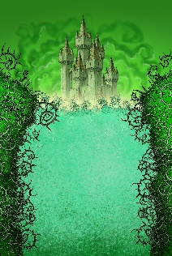

Chapter 6 – Tweezel Berries

Chapter 6 -Word Wizard Challenge

LI: I can identify and discuss techniques and language used by the author to create tone and build tension

1.Find two POWERFUL verbs to add to your Word Wizard Dictionary. Discuss your word selection with your partner/trio.
e.g. hollered, sprinting, charged (like a bull), slamming, skidding, crashing, collided, steamrollering.

2.Discuss why the author might have used these verbs in Chapter 6 - e.g. to make the description of the action more exciting for the reader, to make the description sound fast-paced.

Chapter 7 – Body Pumps

Chapter 7 - Word Wizard Challenges

LI: I am learning to use a variety of strategies to support my understanding of new vocabulary
LI: I can accurately use new vocabulary when creating my own texts

1.Find as many synonyms as possible which the author uses instead of ‘said’. Discuss the author’s choice of words, why doesn’t she just use ‘said’?

e.g. hollered, gulped, cried, asked,mumbled,wailed,exclaimed,whispered,screamed,stormed,squirmed,interjected, sobbing, quizzed, pressed, continued, snorted.

2.Choose two of the synonyms to add to your Word Wizard Dictionary

3. Scan the text to find interesting adverbs used by the author to describe how the characters speak.
e.g. sobbing loudly, said firmly, exclaimed triumphantly, said sternly,said defiantly.
Choose two adverbs to add to your Word Wizard Dictionary.

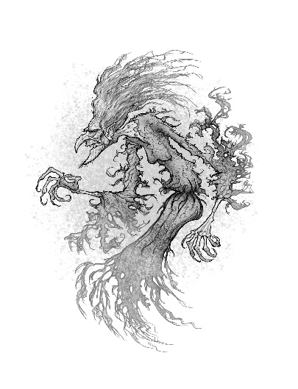

Chapter 8 – Dead Souls Walking

LI: I am learning to summarise a text

Before Reading chapter 8 - write a brief summary of the story so far - only include key information.

Chapter 8 – Reading into Writing

LI: I can identify and discuss how authors use setting descriptions to change the tone and atmosphere of a text

- Read the setting description in the first two paragraphs on page 65 - discuss how the setting changes. How does this change the atmosphere in the story?
- Discuss why the author might have decided to change the setting description? How does it make the reader feel? How does it help the reader predict what might happen to the character, Buttercup?
- Discuss other texts which you may have read or seen in which a change of setting indicates that something important or frightening is about to happen?
- Discuss the differences in how a change of setting is created in books and in films.

Wizards’ Film Production Challenge

Film Literacy

LI: I am learning to identify and discuss techniques and strategies used by film producers to change the tone and atmosphere in a film

LI: I am learning to apply some of the techniques used to create a short film

Watch the clip and discuss techniques used by film producers to build tension.

The clip is from Jurassic Park 1
https://www.youtube.com/watch?v=RFEGDLhezX0

- Skim chapters 6 - 7
2.Work in trios to create a storyboard for the events leading up to the change of setting at the start of Chapter 8. (Storyboard template - include stage directions, props, music etc)
3.Use the storyboard to create a trailer using iMovie - ending on a cliffhanger. (Several sessions)

Chapter 8 - Close Reading

Learning Intention: I can answer a variety of questions relating to a text

Before writing your answers, discuss which of the questions are literal, evaluative and inferential.

- Do you think that Buttercup really saw a boy’s face on the wall? Give Reasons. E.g. I think that Buttercup just imagined that the shadows made a boy’s face because she was feeling frightened and also she doesn’t see them again after she realises that the noise she heard might have been caused by the rolling-pin falling.
- Why had Buttercup not believe in these creatures before? Buttercup thought that the stories of the Mantigh were made up to scare children so they wouldn’t go into Brodick Castle.
- Do you think Buttercup really didn’t believe the stories when she was young? Give reasons. e.g. I think Buttercup might have just said that she didn’t believe in them but she had nightmares about them and was very frightened by the chilling stories her mother told her about them so perhaps she actually did believe in them.
- What was different about the third witch? The third witch was smaller than the other two and looked almost human.
- What type of creatures are Mantigh? Mantigh are witches’ souls, neither dead nor alive and they go out at night to prey on any living things.
- Why did Mogdred despise Silusa? She despised Silusa because she was not a true Night Witch.
- How would Silusa have felt about how Mogdred had treated her after her mother died? Silusa was a good witch with a pure heart so she would have felt very hurt and scared by Mogdred’s actions.
- Why did Mogdred want the Cauldron of Undry? Mogdred had a thirst for power and was involved in dark magic. She wanted the Cauldron as she heard that it could bring the dead back to life.
- Find evidence from Chapter 8 which shows that Mogdred is a very clever and cunning character? Mogdred shows that she is very clever and cunning when she uses Silusa to meet the Buddhists as they would trust her more.
- Why did Silusa decide not to find and kill Buttercup at the end? Silusa probably decided not to bother with Buttercup as she had already got some life force from killing the mouse.
- How do you think Buttercup is feeling at the end? I think Buttercup is feeling relieved that she was not found but also very frightened about the prospect that Silusa will return.
- How do you think Buttercup will be feeling about Blade? She might be feeling upset that Blade has left her alone or she might be worried that the Mantigh have killed him.

Chapter 8 - Storytelling Challenge

Learning Intention: I can plan and create a traditional tale

Learning Intention: I am learning to vary my pace, gesture, tone and expression to engage an audience

  - In pairs/trios discuss your favourite fairy-tales or stories from Scottish folklore.
  - Discuss how the stories are often used to give a message or teach a lesson to children.
  - Discuss the structure of traditional stories .
  - Listen to the teacher telling a traditional Scottish tale. ( The following website provides a list of traditional Scottish tales) https://www.electricscotland.com/kids/stories/
https://www.youtube.com/watch?v=KyXQiYEyf1M
  - In pairs/trios create your own fairy-tale – this will be planned and created verbally.
(The Success Criteria should include: adherence to the structure of traditional stories, the stories must convey a lesson, the need to vary their pace and tonevoice and facial expression to engage the listener.)

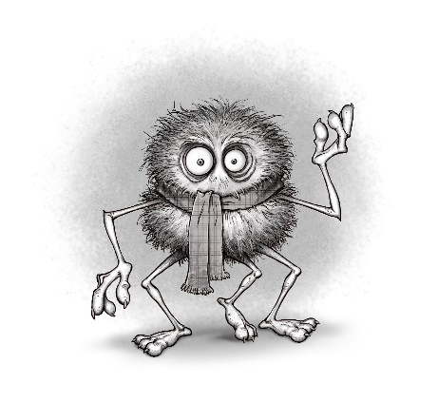

Chapter 9 – Number 1 Goatfell

Word Wizard Challenge

LI: I am learning to apply a variety of strategies to support my understanding of new vocabulary

Use the clues to complete the crossword.

Hastily- Adverb to describe how someone moves or talks in a quick manner pg75
Massive - Adjective to describe something or someone that’s is huge. pg 76
Devastation - Noun. A scene of complete destruction pg 78
Defeat - Verb. To win against or conquer an opponent in sport or battle pg81
Descended - Verb (past tense). To go down. Synonym, lowered.pg82
Tome - Noun. A very large book. pg 81
Illusion - Noun. An pg 85

Chapter 9 Question Challenge

LI: I am learning to create different types of question about a text

With your partner/trio create three literal questions, two personal and one inferential question for another reading pair/trio to answer.

Coding Challenge

LI: I can apply my knowledge of computer programming to respond to a design challenge

Your challenge is to design and market a game involving some of the characters from the novel. (This could be done using ‘Scratch’ – alternatively the children could create a board game involving the characters.)

Planning page - age group, aim of the game, friends and enemies, special powers, gadgets, how the scoring system works, bonus points.

Name of the game
Aim
Characters
Special Powers
Gadgets
Explain how the scoring system works

- Trial the game
- Improve and create the final version
- Create a promotional advert for the game
- Post on Thumble Tumble Twitter page @ah_proctor
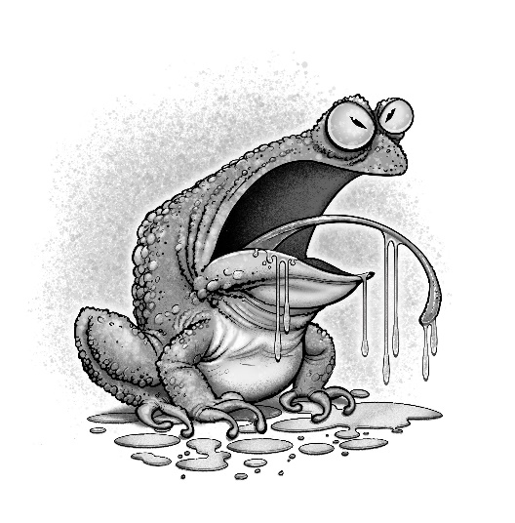

Chapter 10 – The Watcher

Word Wizard Challenges
LI: I am learning to apply a variety of strategies to support my understanding of new vocabulary

LI: I can accurately use new vocabulary, verbally and when creating my own texts
- Scan the text for 2 interesting words to add to your Word Wizard Dictionary.
- Check your definition using a dictionary.
- Discuss the words with your partner or trio.
- Challenge partner/trio to use at least one of the words you have added to your dictionary in their written or oral work this week. They will earn a point for each correct use of the word.

Keep score using the Word Wizard Score Card and add up the points at the end of the week. F points will be awarded for each appropriate use of the word.

Who will be the Word Wizard Champion?

Word Wizard Score Card
Word | Evidence of using the word | Points
e.g.Hideous | Used it in my homework sentence - The hideous creature disappeared in a puff of smoke. | 5

Final Score:____points

Health and Well-being – Is Torgle Being Bullied?

LI: I understand that there are people I and others can talk to, and ways to get support when experiencing bullying

- With your partner/trio discuss how Torgle is feeling at the beginning, middle and end of Chapter 10. Record your descriptions of his feelings using the character portrait below

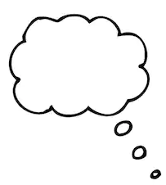

- How do you feel about Torgle at the end of Chapter 10?

- Torgle is feeling bullied and threatened by Serena. He has sent you a message, looking for advice. Imagine Torgle is your friend and write a reply, giving him advice on how he can get help
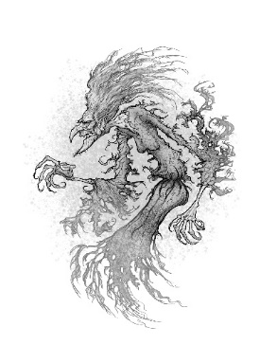

Chapter 11 - The Sleeping Gardner

Reading into Writing

LI: I can identify and discuss the features and structure of an imaginative text

After reading Chapter 11 add the key details of the story about ‘The Sleeping Gardner’ to a Story Mountain Template.

Writing Challenge – Spooky Stories!

LI: I am developing my ability to write imaginative stories

Revisit the elements of an exciting imaginative story - (setting, structure- building up the tension, character descriptions, Word Wizard vocabulary, similes and metaphors).

The children will use this discussion to set the success criteria which you will use to write your own amazing imaginative text.

Choose a character from the list below or come up with one of your own, then use the Story Mountain template to help plan your own spooky story involving your chosen character and the Mantigh.

Character suggestions: a schoolchild who has wandered away from his class during a school trip to the Isle of Arran, a history vlogger who wanted to find out about the mysterious Brodick Castle, a ‘ghost hunter’ who wanted to make a T.V. show about the mystery of the Mantigh, a supermarket delivery person who was given the wrong address and arrived at Brodick Castle, after sunset by mistake.

After writing and editing your text, share your stories with the author A.H. Proctor by email: info@thumbletumble.co.uk or on twitter @ah_proctor. If she’s impressed, she might award the author of the best story with a bar of ‘Scoffolicious Chocolate’, handmade by Isla, one of the Good Witches, on the Isle of Arran.

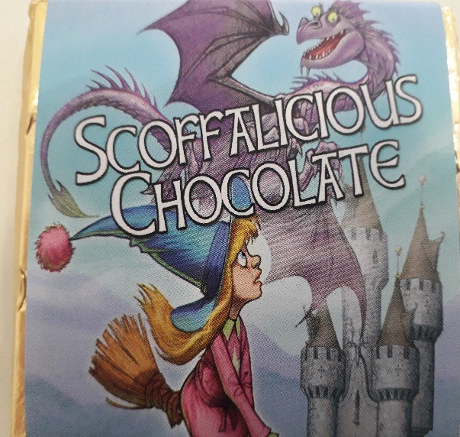

Chapter 12 – Book Shower

Health and Well-being – Why do some people bully others?

LI: I can identify and discuss how certain emotions can affect how we behave

- Discuss the reasons why some people become bullies.
- Discuss the similarities between Serena’s treatment of Torgle and Mogdred’s treatment of Serena.

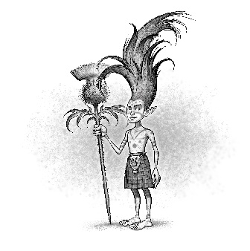

Chapter 13 – Attack of the Thistle Pixies

True, False, Justify

LI: I can use evidence to answer questions and to contribute my opinions about a fiction text

Tick the statements below as being True or False. Justify your answers to your partner/trio by using evidence from the text. You might not always agree but that’s ok as long as you can justify your opinion or answer.

Statement | True | False
McCools traveled to the Holy Isle in his magic elevator.
Kyle was a mischievous Thistle Pixie.
Jock’s enormous body was always a disadvantage.
The Thistle Pixies chose tartan kilts to make them stand out in a crowd.
Jock was a very caring and considerate dragon.
McCools was very knowledgable.
The author used stereotype when creating the Witch Trolls characters, Gorgour and Lumpsila.
Thumble Tumble’s ability to successfully cast spells is improving.
Thumble Tumble is jealous when Jock is praised by McCools.
McCools really dislikes Thumble Tumble.

Art

LI: I can create images, showing an awareness of detail

  - Re-read the descriptions of the two Witch Trolls and use the description to draw a portrait of them. Only show your picture to your partner/trio when you have both/all finished. Discuss similarities and differences.

  - Each pupil will write a brief description of their own Thistle Pixie Clan leader. They will then swap with a partner and draw the image, using their description.

Chapter 14 – Groucho’s Gauntlet

Close Reading

LI: I can use evidence from the text to answer questions and complete tasks after reading

- What type of literary technique has the author used in the title of Chapter 14? The author uses alliteration.
- Use this technique to create a title for a chapter about Lumpsila and Gorgour. e.g. Lovely Lumpsila and Gorgeous Gorgour.
- Scan the text to find evidence to show that Jock is very protective of Thumble Tumble. At the beginning of the chapter Jock shows that he is very protective of Thumble Tumble when he is worried that Kyle has tricked Thumble Tumble and at the end of the chapter he held his wing out to act as a trampoline to break her fall.
- Do you think Groucho’s name suits his character? Give reasons. Groucho sounds like the word grouchy and suits the character’s appearance because he has a sour expression on his face; however, it does not suit his personality because he has a ‘cheery tone’ of voice and is ‘very pleasant and not grouchy in the least’.
- Why might Thumble Tumble not remember having met Groucho before? I think the battle took place when Thumble Tumble was a baby and that is why she cannot remember meeting Groucho.
- Is Thumble Tumble a considerate girl? Give Reasons for your answer. Thumble Tumble shows that she is a considerate girl when she helps save the ants from the falling cauldrons and also when she was worried that she may have crushed them.
- Why had Groucho made Thumble Tumble run through the gauntlet? Groucho wanted to test Thumble Tumble’s character to make sure that she was kind and pure of heart as he does not want the Cauldron of Undry to fall into the wrong hands.
- What simile was used to describe Hibert? The author uses the simile, ‘Hibert’s rope was so tight it made him look like a human egg-timer’.
- Create a simile to describe Groucho’s thin appearance. e.g. Groucho’s face was a sour as a lemon.
- Why do you think Groucho won’t tell Thumble Tumble about why her mother died? I think that Groucho will not tell Thumble Tumble because she was the one that her mother was protecting when she died and he does not want to make her feel guilty.
Word Wizard Challenge

LI: I can apply a variety of strategies to support my understanding of new vocabulary

  - Scan the text to find synonyms for the following words:
Words | Page number | Synonym
Sick | 115 | Nauseous
Exploded | 118 | Detonated
Danger | 122 | Jeopardy
Injured | 122 | Maimed

  - Scan page 120 for the word fastidious, write your own definition and state what class of word you think it is. Use a dictionary to check your answer and add it to your Word Wizard Dictionary.

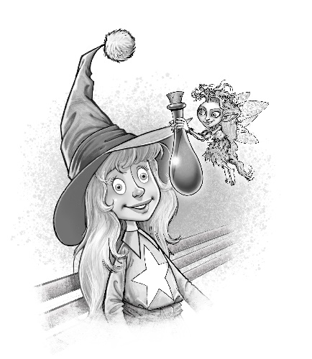

Chapter 16 – Fairy Dew

LI: I can make predictions during and after reading

Predictions
- McCools’ said, ‘But now that Mogdred knows who she is, perhaps it’s time to stop hiding the truth from her and start training her?’ What is the secret that Isla and the other characters, are hiding from Thumble Tumble? What type of ‘training’ is McCool referring to?

- Why do you think Mogdred would want to kill Thumble Tumble?

Themes

LI: I am learning to identify and discuss the writer’s theme

Re-read page 132 starting from, ‘Poor Silusa,’ said Thumble Tumble sadly.

Discuss what theme(s) comes up from this paragraph. (E.g. Good V Evil, using good to stop evil destroying the world, people are mostly good mixed with a little evil).

Discuss how these themes have come up throughout the novel.

- Give examples of how some characters have shown good and bad sides to their personality.
- Give examples of characters who have allowed themselves to be influenced by the evil actions of others.
- Give examples of characters who seem to be purely evil and those which are purely good.
- Give examples of characters who are taking action to make sure that evil does not destroy the lives of others.
- Discuss why you think the author chose to include the good v evil theme? What message do you think the author is trying to get across to the reader? (Link to messages conveyed through traditional fairy stories)
- Give real life examples of people you know or people you’ve learned about in school or from the media who have used positive actions to stand up for what is right and to make the world a better place for everyone.
(Children make connections to their own daily life and general knowledge of past or current issues)

Reading into Writing

LI: I can identify and discuss the features of a biographical report

Study the following extract about Martin Luther King. Identify the features of a biographical report.

https://www.ducksters.com/biography/martin_luther_king_jr.php

https://www.theschoolrun.com/homework-help/dr-martin-luther-king-jr

Writing – Biographical Report

LI: I can write a biographical report

Write a report on a person whom you admire because they have stood up for the rights of others and made a positive contribution to the world. (E.g. Malala Yousafzai or Greta Thunberg )

  - Use what you know about the features of a biographical report to create success criteria.
  - Carry out research and make notes
  - Use your notes to plan and write the report
  - Remember to include your sources

Chapter 17 – Assault on Brodick

Word Wizard Challenge

LI: I can apply a variety of strategies to support my understanding of new vovabulary

Scan the text to find synonyms for the words below
Word | Page number | Synonym
Still | 134 | Motionless
Spooky | 134 | Eerie
Painful | 134 | Agonising
Disappear | 137 | Vanish

Summary:

Provide a brief summary of the first part of the battle, only including the most important details from the chapter.

Chapter 18 – Bridge ‘Club’

Discuss how the author, once again, focuses the reader’s attention on the themes of good and evil in the story.

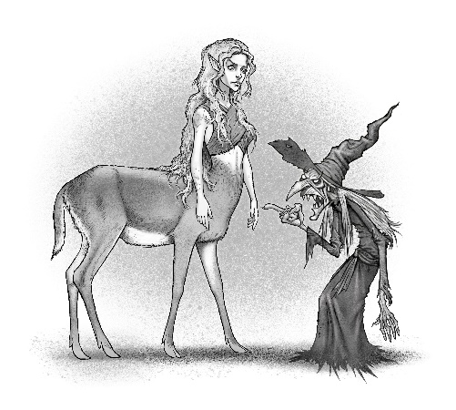

Chapter 19 – Mogdred’s Vow

- Read the first four lines of page 146. Why do you think the author chose to start the final paragraph with such a dramatic setting description?
- What clues has the author given which show that the story is to be continued?
- What questions would you like to find out the answers to from the third novel?
- Make 3 predictions about the sequel to this novel. Write them down, before reading the third book in the Thumble Tumble series, ‘Thumble Tumble and the Eagalach Cup’.

Review Activities

Book Club Challenge

Join up with another pair or trio to create a book club vlog about ‘Thumble Tumble and the Cauldron of Undry’.

Before filming, plan a list of topics or questions you would like to discuss with your book club.

After planning, work together to decide on a final list, each book club member can ask two questions or raise two points for discussion. All members of the group will have the opportunity to contribute their opinions.

Suggestions - Questions and Topics for Discussion might include:
- Genre: What is the genre of the book? Do you like this genre? Have you read any other books or seen any films similar to this genre?
- The writer’s style - what did you like most about the writer’s style? Describe how the writer used humour to create funny characters and to describe funny scenes?
- Characters - Who was your favourite and least favourite character? How did the author help you get to know the characters?
- Setting - what did you think of the way the author created different settings? Why did she change the setting descriptions throughout the book? What was your favourite setting description and why? What have you learned about creating setting descriptions?
- Themes - What was the main theme? What other themes arose?
- Predictions - what do you predict will happen in the opening chapter in the next book? Will that be the last book in the series?

Tweet the Author
- With your partner/ trio discuss questions would you like to ask the author or what advice about imaginative writing you would like from her?
- Share these with your class and then decide on the top 5 questions you would like to ask in a tweet to: ah_proctor

Suggested Links to other Curricular Areas

The book is set on the Isle Arran and surrounding islands therefore a natural link could be made with Social Studies experiences and outcomes which relate to Scotland (People, Place and Environment). Possible contexts for learning could include: Scottish Tourism, Scottish Folklore, Comparing Local Environment to life on a Scottish Island.

Health and Well-being:

Themes which arise in the novel include: friendship, kindness, anger, revenge, bullying and threatening behaviour, standing up for the rights of others. Therefore there are various links which can be made with the Health and Wellbeing Experiences and Outcomes relating to Mental and Emotional Wellbeing and Social Wellbeing. Possible contexts could include: Developing Positive Relationships, Conflict Resolution, How to Identify and Address Bullying.

Expressive Arts:

Art
- Character portraits
- Class display of the setting
- STEAM/Art – creating 3D models of characters or their houses, for e.g McCools’ home.

Drama:

The novel also provides ample opportunities to engage the children in a variety of drama conventions. For example:
- Exploring events or characters through ‘Freeze Framing’
- Exploring character view- points using ‘Hot-seating’
- Discussing important events or scenes using the ‘Marking the Moment’ technique
- Exploring character dilemmas by engaging the children in a ‘Conscience Alley’ activity

STEAM

- Exploring scientific concepts of force and gravity through the Flower Nymph design challenge.

Digital Literacy

The novel provides numerous opportunities to use digital technology to enhance the children’s learning:
- Creating film trailers
- Conducting online research about the Isle of Arran and surrounding areas
- Using touch stop-motion animation to retell traditional fairy-tales or traditional Scottish stories
- Using technology to communicate with the author or with children from a primary school in Arran

Computer Science

- Using coding technology to create interactive games involving the characters.

- Create a maze, based on the ‘Devil’s Maze’ in Chapter 3, using junk materials or drawing on the playground with chalk. Children can practise offline coding skills by issuing directions for a partner who is blindfolded to escape the maze. An extension of the activity could involve children using online coding skills to navigate a Beebot or Sphero through the maze.

Additional Literacy Activities:

Higher Order Thinking Skills

- Using thinking routines and planning for effective questioning to develop children’s ability to analyse and evaluate texts. Suggested thinking routines:
  - Think, Pair, Share
  - I see, I think, I wonder

- Question cube – With a different higher order question stem on each face of the cube
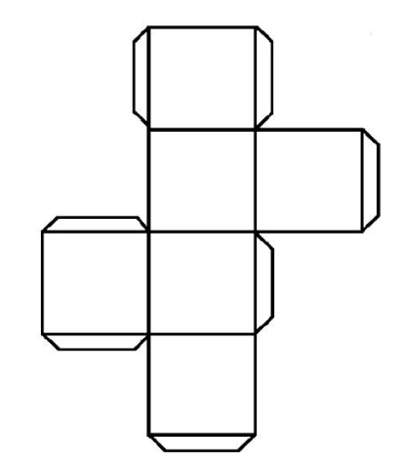

- After Reading Activity Cube – with a different activity related to the novel on each face of the cube, for e.g. creating film poster, a character wanted poster, design a character’s bedroom, write a play script, create a comic book of a scene or event, act out a scene with your peers.

- Tweets from different characters or messages on WizAp regarding events from a chapter.

- Vocabulary Bingo – write 15 new words which the children have learned from the text. Children write 12 of the words in their jotter. The teacher or a pupil will call out synonyms or definitions which the children will match to the list of words they have chosen. The child or children to match all twelve first will shout, ‘Bingo’!

- Create a ‘Guess Who’ style card game for the different characters

- Write a fairy story or traditional Scottish story for younger children

